**BIBA Project 2**

**Name:** Praveen kumar

**Mail:** [praveenkumarkorupalli@gmail.com](mailto:praveenkumarkorupalli@gmail.com)

**Project statement**

Use Azure Data Factory to move and organize data in Azure Data Lake Storage, and leverage Azure Databricks for data processing and analytics on the data stored in the Data Lake.

**Project Overview**

**The primary goal of this project is to streamline the data movement and organization process within Azure Data Lake Storage, while also enabling powerful data processing and analytics using Azure Databricks. The project aims to enhance data management, improve data quality, and enable advanced analytics for better decision-making.**

**Project Requirements**

* Azure Data Factory
* Azure Databricks
* Azure Data Lake Storage
* Optimized Data Storage and Retrieval
* Documentation
* Testing and Validation

**Prerequisites**

* **Azure Subscription:** An active Azure subscription to deploy and manage resources.
* **Access Rights:** Appropriate rights for Azure Data Factory, Data Lake Storage and Databricks.
* **Data Sources:** Access to the source data that needs to be moved to Azure Data Lake Storage.

**Architecture Diagram**

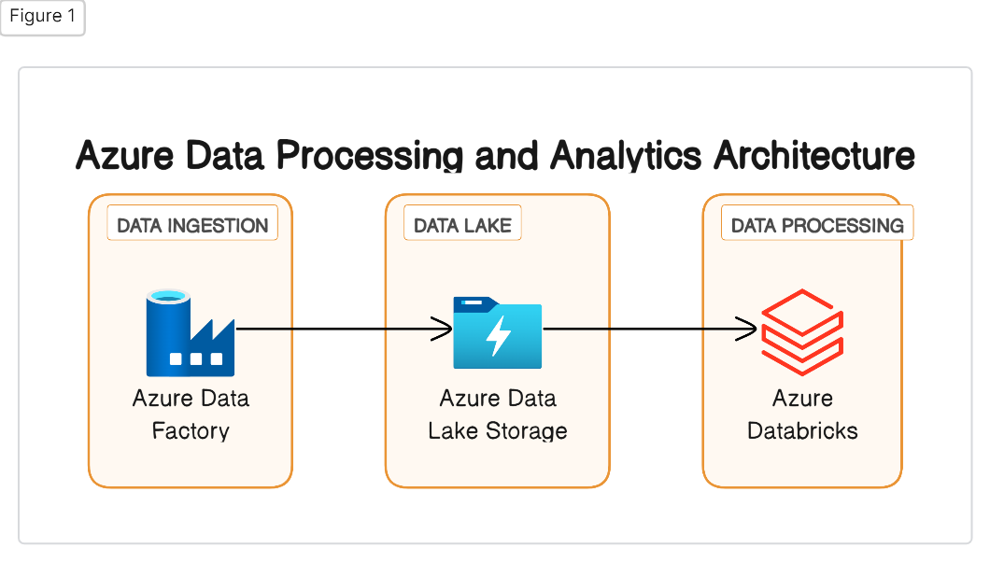

**ER Diagram**

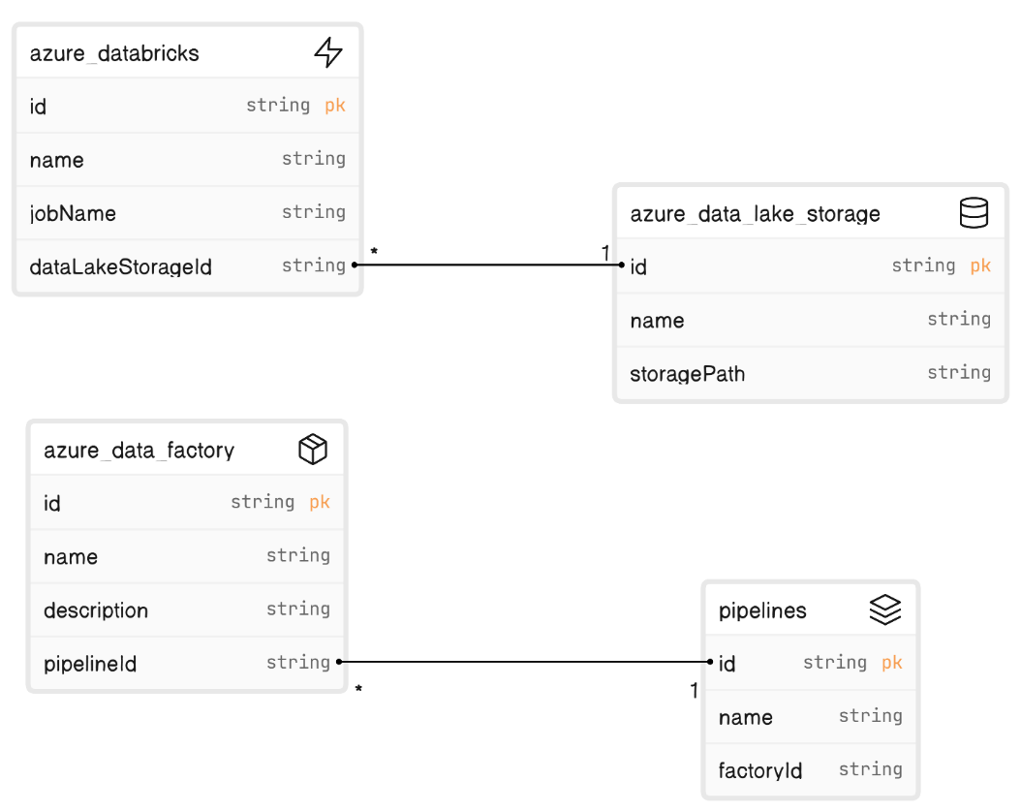

Azure data factory for data movement and organization

Azure data lake storage for storing data

Azure databricks for data processing and analytics

**Tools and Technologies used in project**

* **Azure Data Factory**: For data movement and organization
* **Azure Databricks:** For data processing and analytics
* **Azure Data Lake Storage (ADLS):** For storing structured and unstructured data
* **Azure Monitor and Logging Services:** For monitoring and logging the data pipeline.

**Source Data Files:**

Source file is taken from the <https://www.stats.govt.nz/large-datasets/csv-files-for-download>

[gross-domestic-product-september-2023-quarter-visualisation.csv](https://www.stats.govt.nz/assets/Uploads/Gross-domestic-product/Gross-domestic-product-September-2023-quarter/Download-data/gross-domestic-product-september-2023-quarter-visualisation.csv)

**Execution Overview**

* **Set Up Azure Data Lake Storage:**
* Create necessary containers and directories to organize data.
* **Configure Azure Data Factory:**
* Set up linked services to connect to various data sources and Azure Data Lake Storage.
* Define data pipelines for data movement and organization.
* **Data Movement:**
* Use Azure Data Factory to move data from sources to Azure Data Lake Storage.
* **Azure Databricks Integration:**
* Configure Azure Databricks workspace and cluster.
* **Data Processing and Analytics:**
* Develop notebooks or jobs in Azure Databricks for processing and analytics.
* **Monitor and Log:**
* Set up Azure Monitor and Logging services for tracking the data pipeline's performance and health.

**Implementation Steps**

* **Set Up Azure Data Lake Storage:**
  + Create necessary containers and directories to organize data.
* **Configure Azure Data Factory:**
  + Set up linked services to connect to various data sources and Azure Data Lake Storage.
  + Define data pipelines for data movement and organization.
* **Data Movement:**
* Use Azure Data Factory to move data from sources to Azure Data Lake Storage.
* **Azure Databricks Integration:**
* Configure Azure Databricks workspace and cluster.
* **Data Processing and Analytics:**
* Develop notebooks or jobs in Azure Databricks for processing and analytics.
* **Monitor and Log:**
* Set up Azure Monitor and Logging services for tracking the data pipeline performance and health.

**Practical implement on Azure Portal:**

* Login to the **Azure portal.**

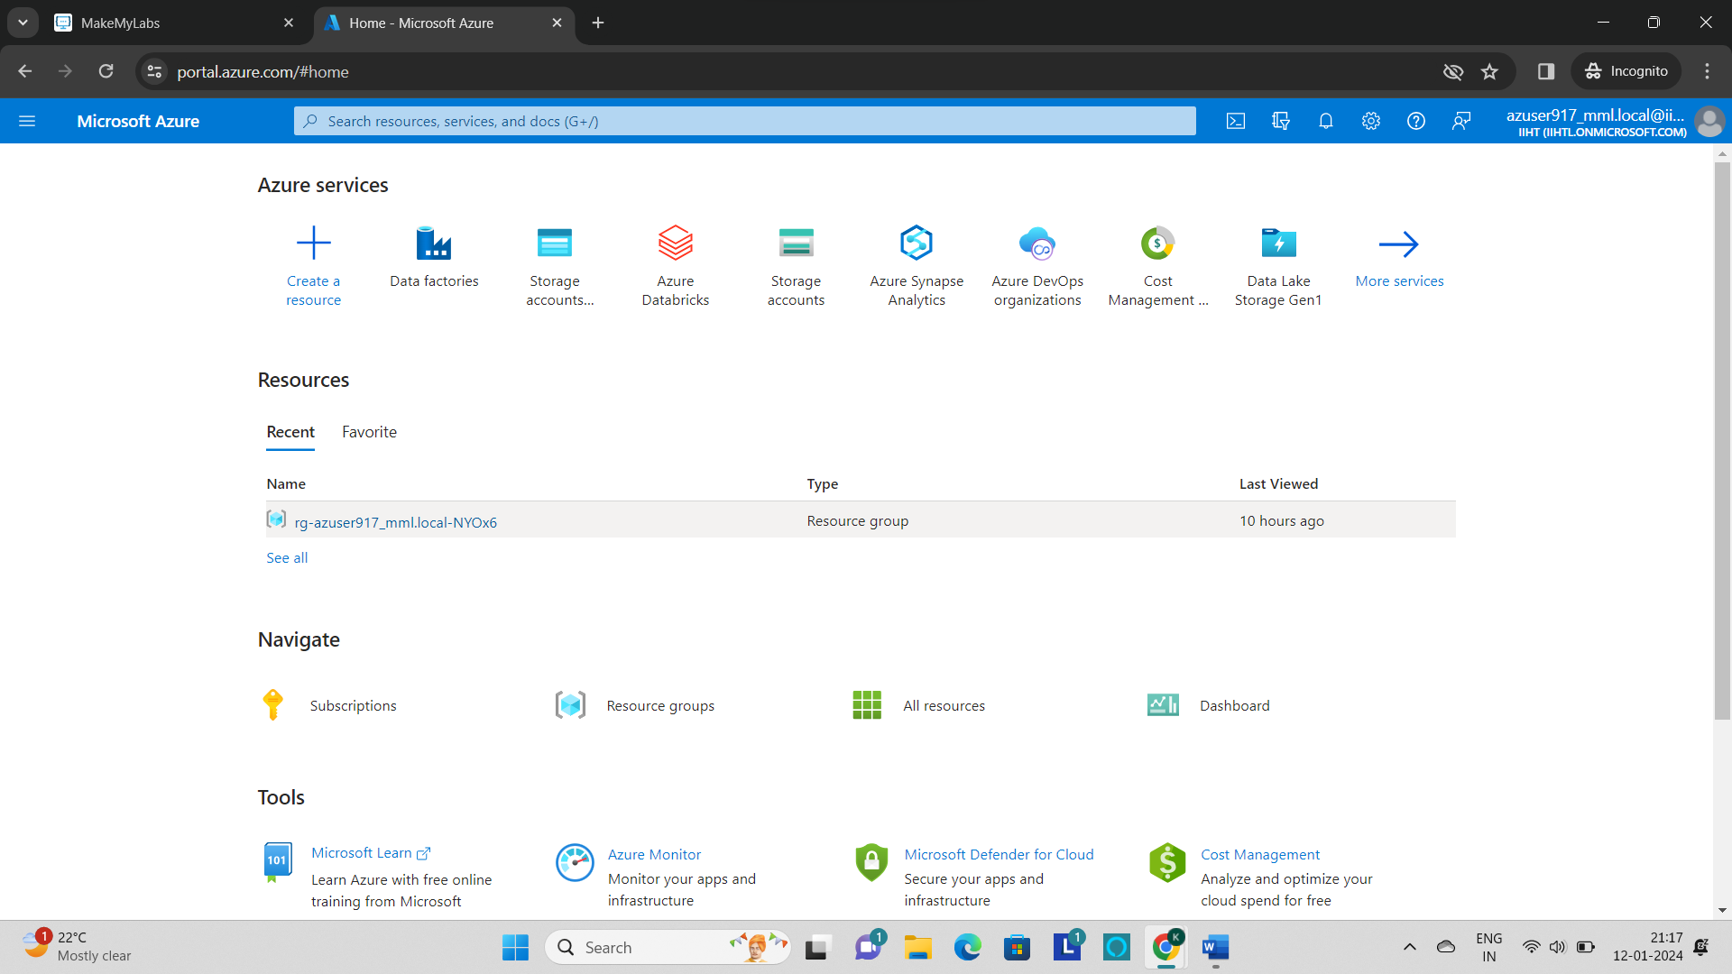

* Search for the **Storage account** and create a storage acoount.

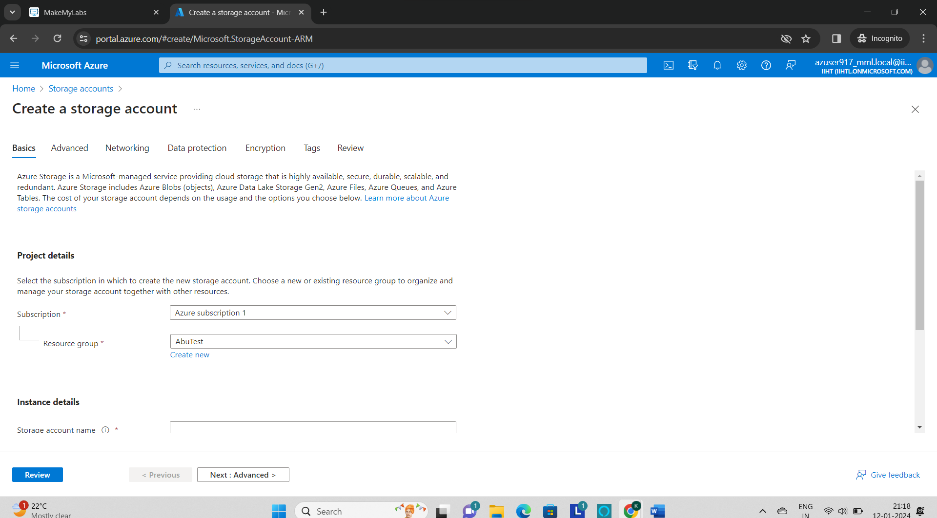

* Fill the details and click on create to create a **storage account.**

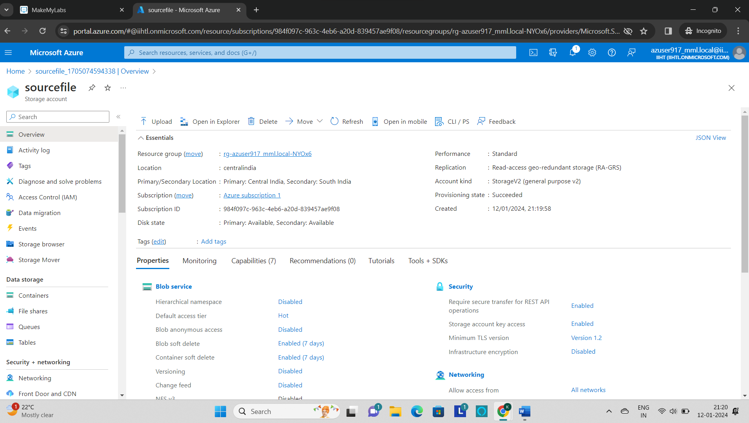

* Now the storage account named as **“sourcefile”** is created.
* Create a **container** named as **“inputcontainer5”** to store the file.

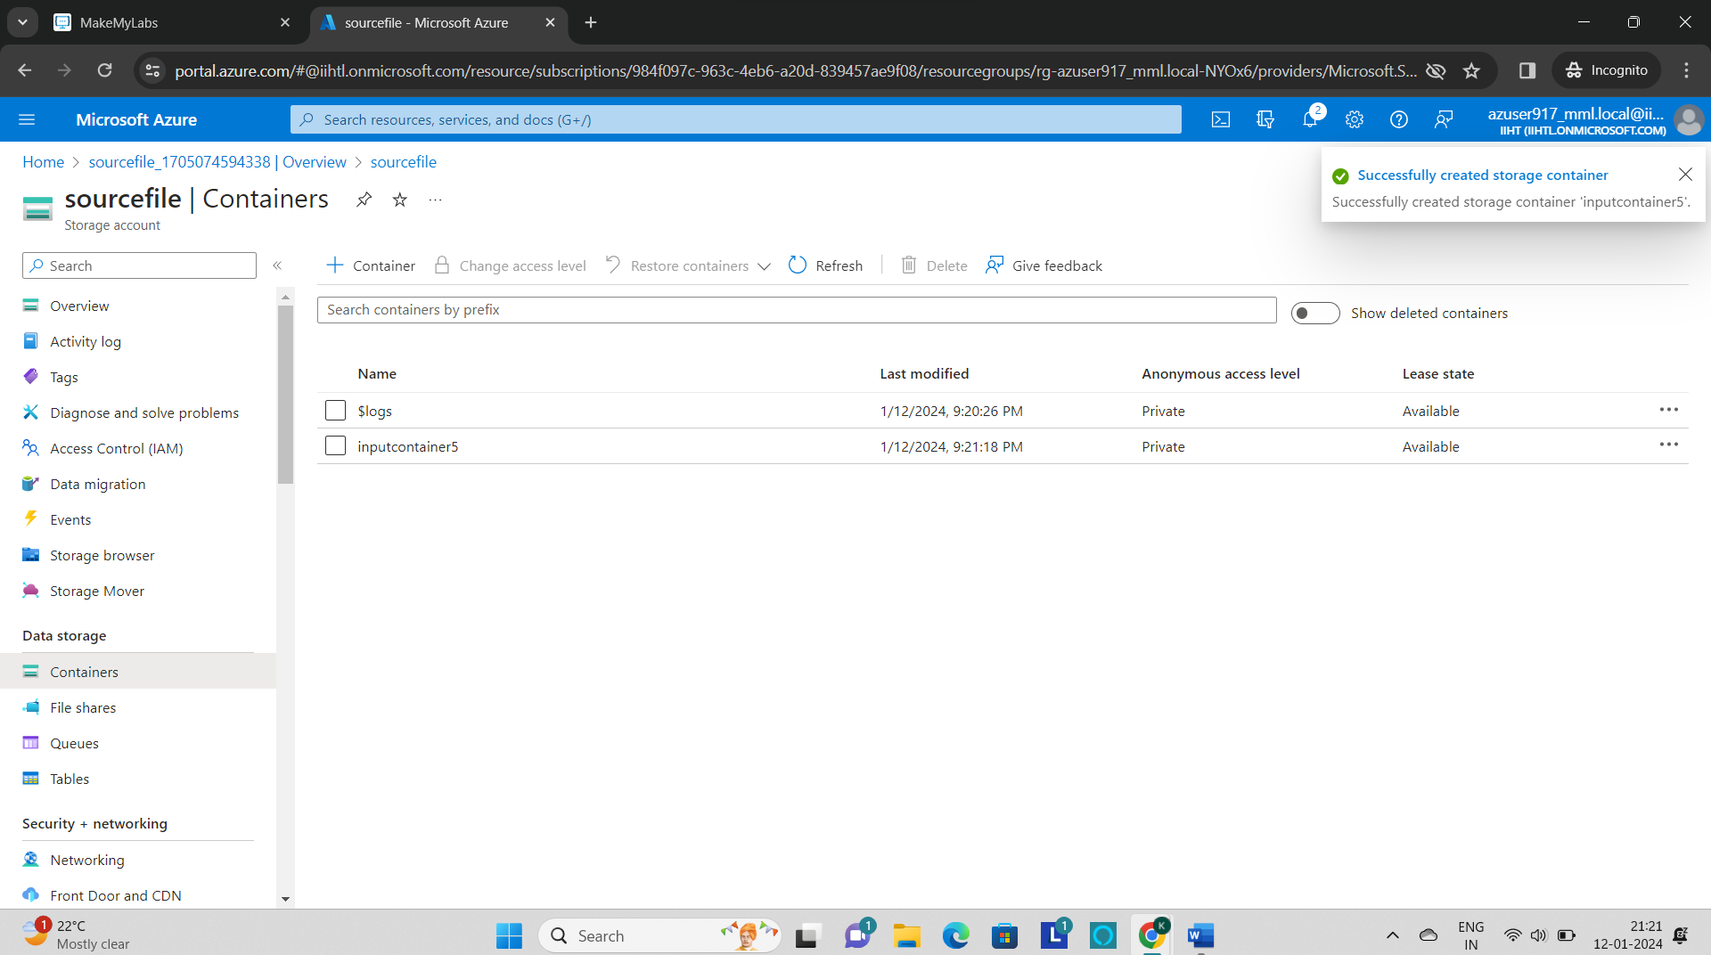

* Go to the container and click on **“upload”** to upload the file in the container.

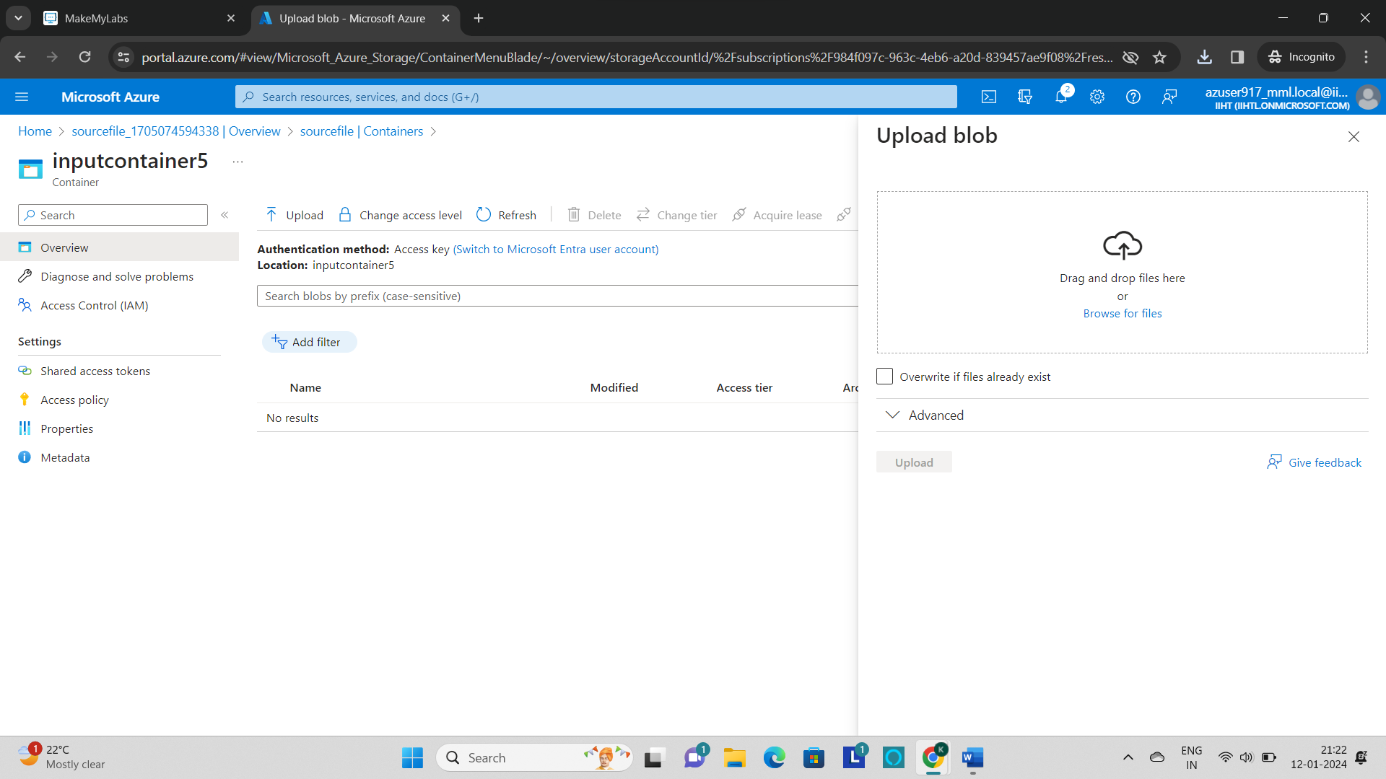

* Browse the file in your local system and click on **“upload”.**

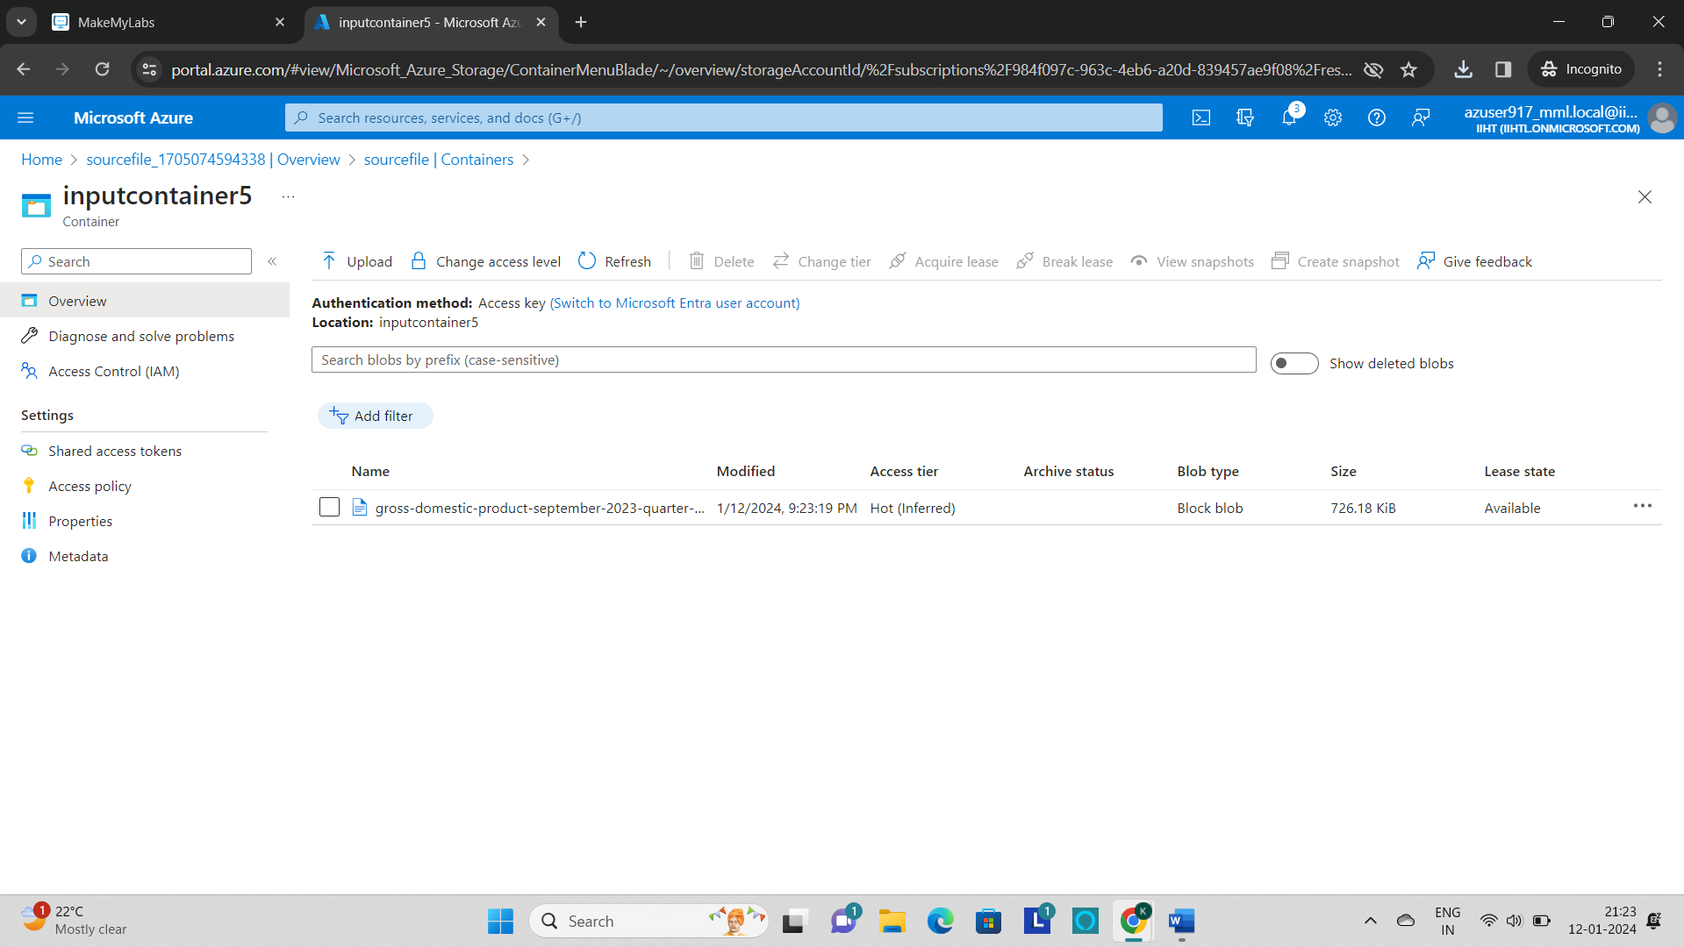

* Go to azure home page and select the **“Azure databricks**” and create the new azure databricks workspace.

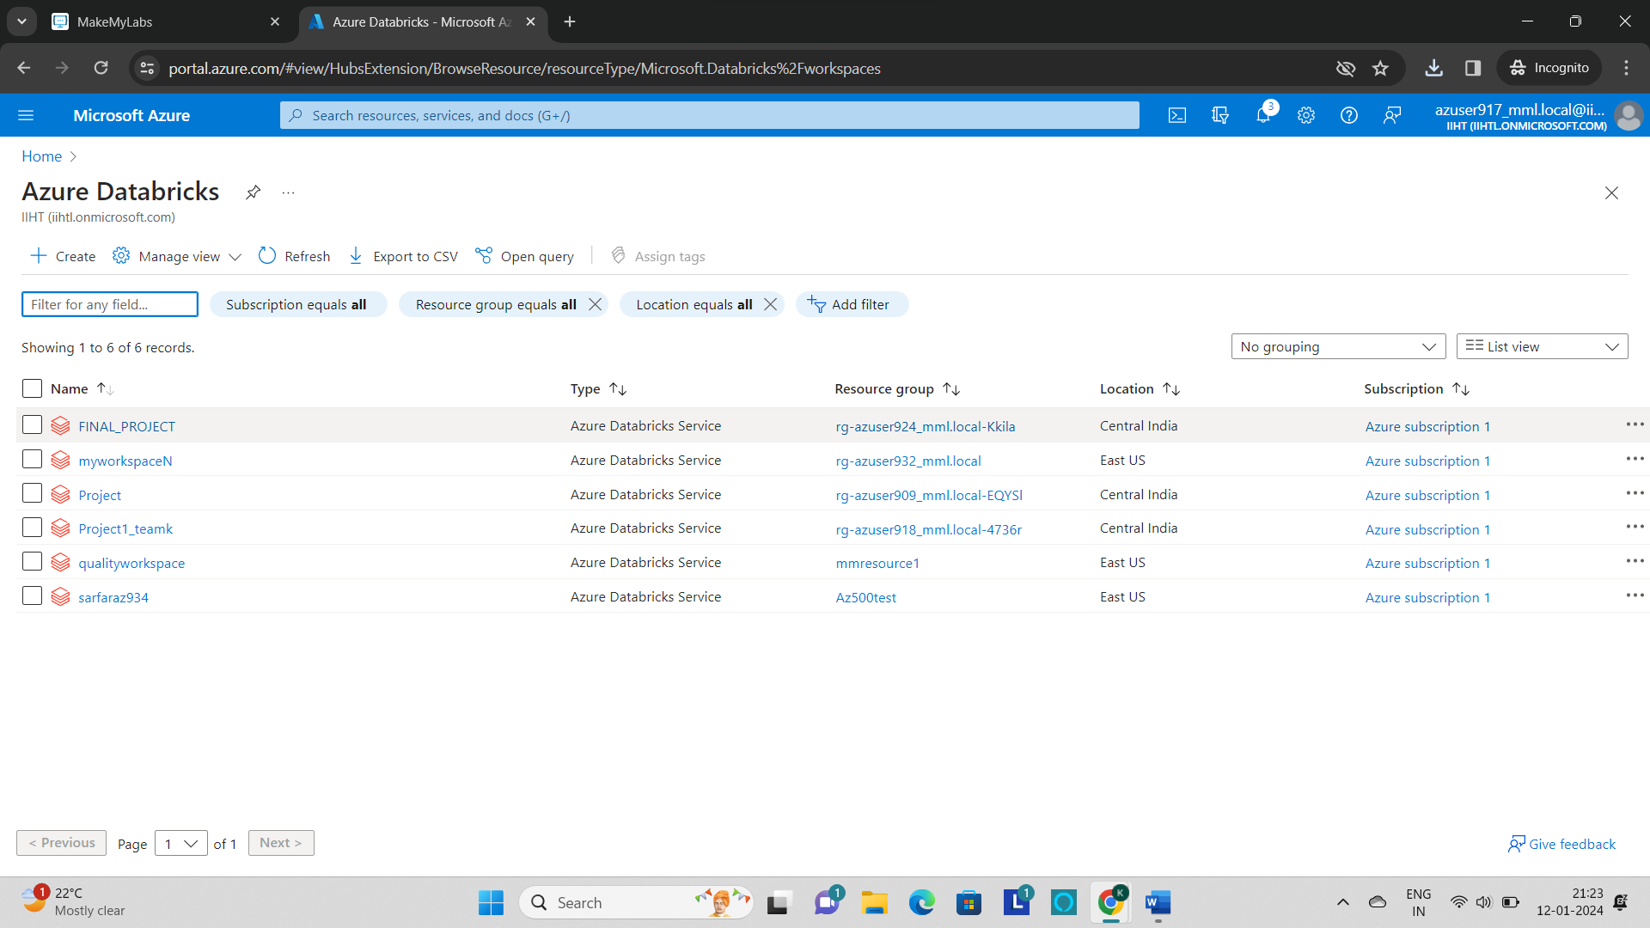

* Click on **“+ create”** to create a new databricks workspace.

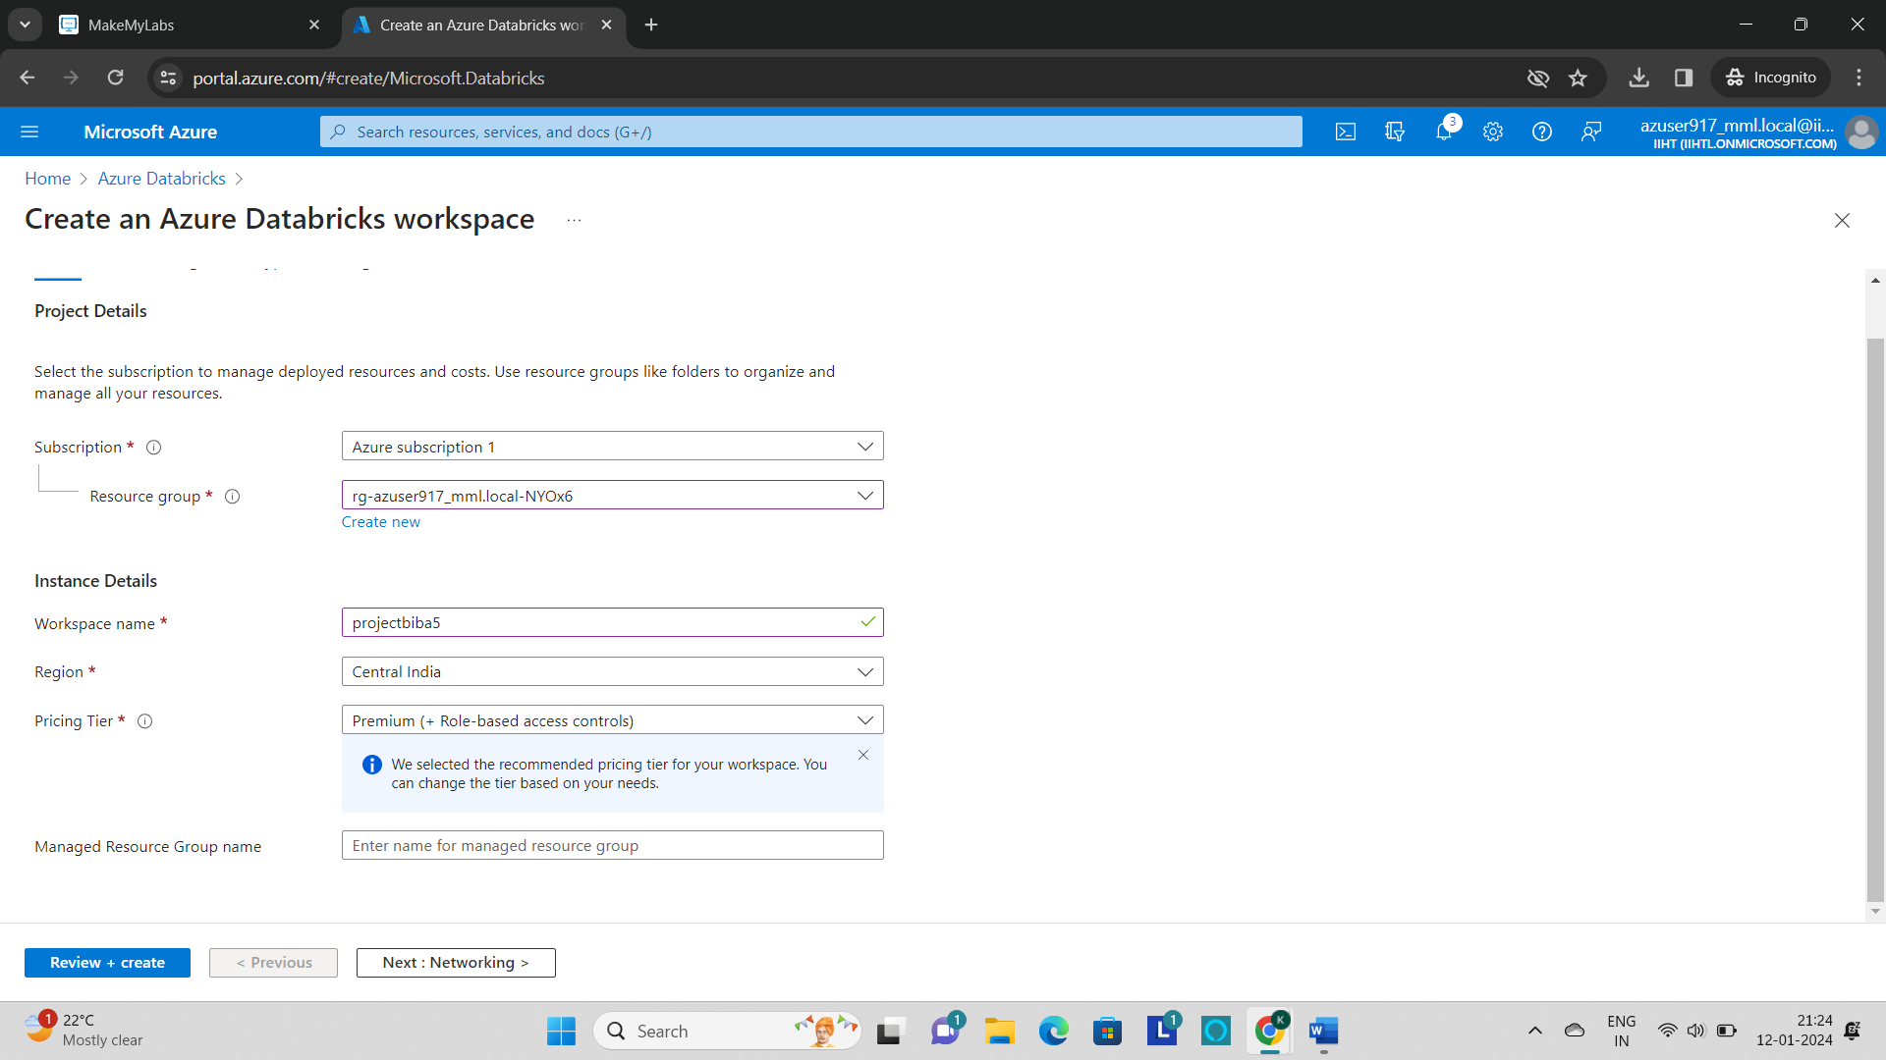

* Fill the project details and instance details and click on **“Review+create”.**

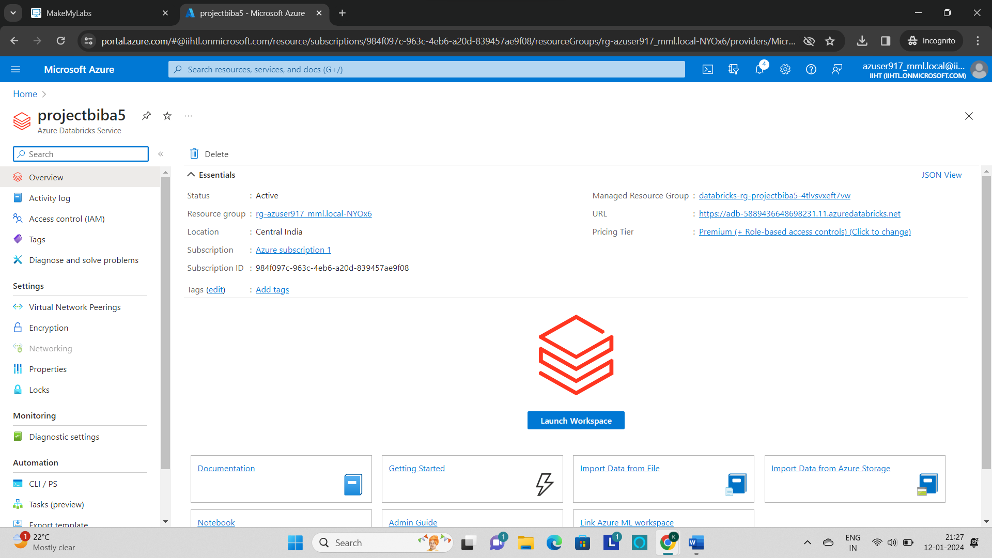

* After the creation of workspace, click on **“Launch Workspace”** to launch the azure databricks.
* Now click on **“Compute”** and create the cluster.

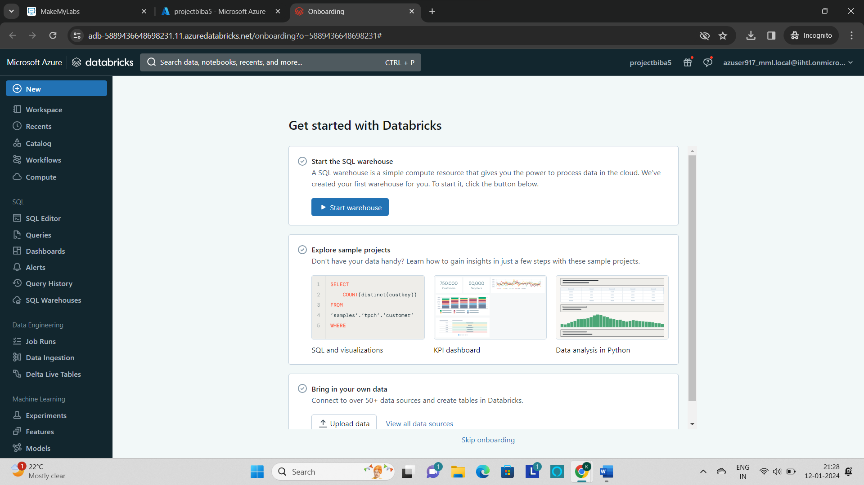

* Fill the required fields as per the requirement and click on **“Create Compute”.**

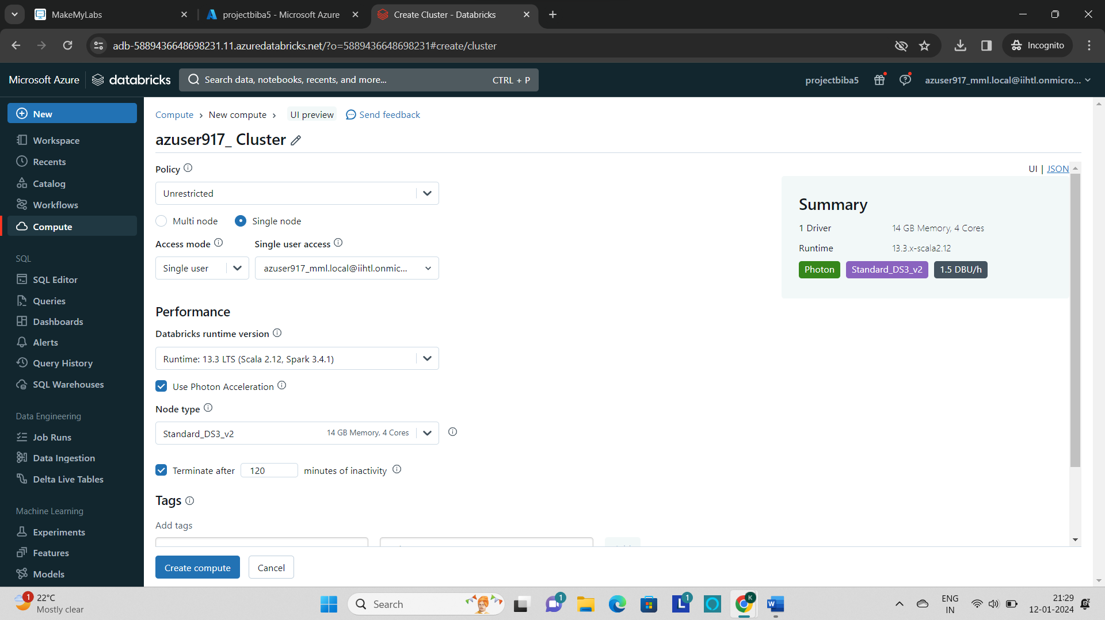

* The cluster is ready and good to use.

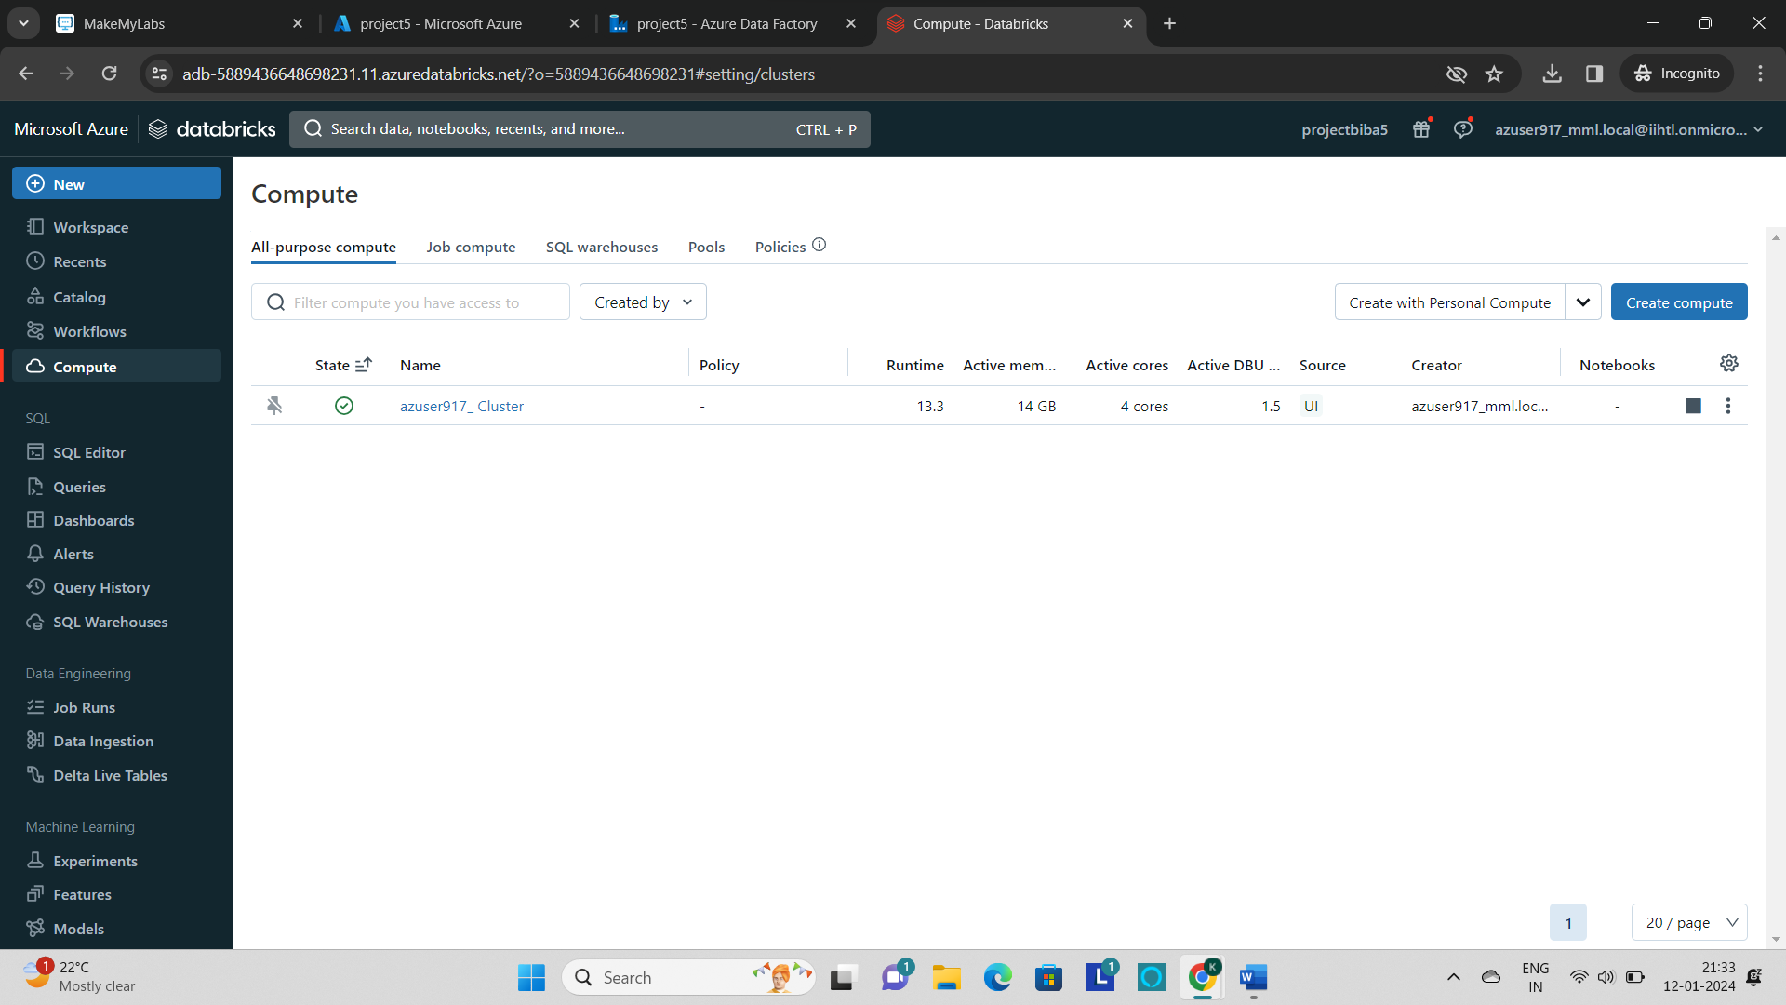

* Now create a **notebook** and connect the cluster.
* Now to **mount the storage account** to the azure databricks use the below code

**Code:**

storage_account_name = “<storageaccountname>"

container_name = "containername"

mount_point = "/mnt/mount_name "

# Use the access key obtained in Step 1

storage_account_key = "<key>"

# Create the mount point

dbutils.fs.mkdirs(mount_point)

# Mount Azure Storage

dbutils.fs.mount(

source = f"wasbs://{container_name}@{storage_account_name}.blob.core.windows.net/",

mount_point = mount_point,

extra_configs = {f"fs.azure.account.key.{storage_account_name}.blob.core.windows.net": storage_account_key}

)

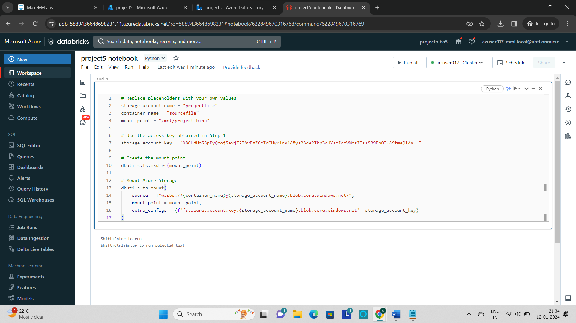

* Now copy the above code to the cell and replace the **storage account name, container name, mount_point** and **Storage_account_key** with the created storage account values.
* Now run the cell and it returns the True value.
* Now load the file into the databricks by using the **“spark.read.load(“filepath”)”.**

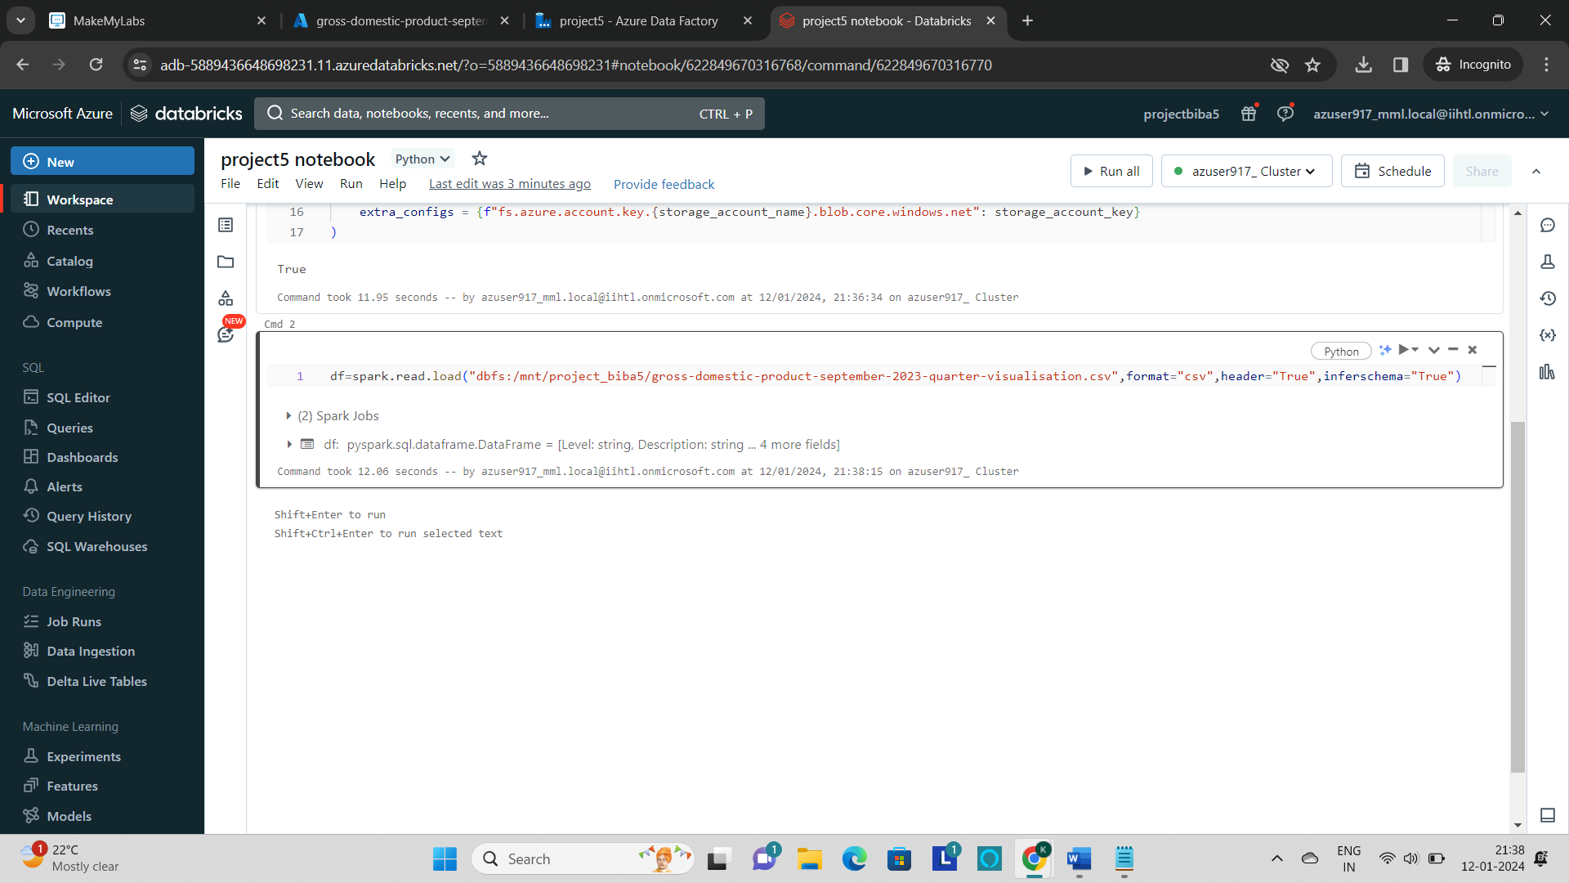

* **display()** is the command used to display the contents of the file in table.

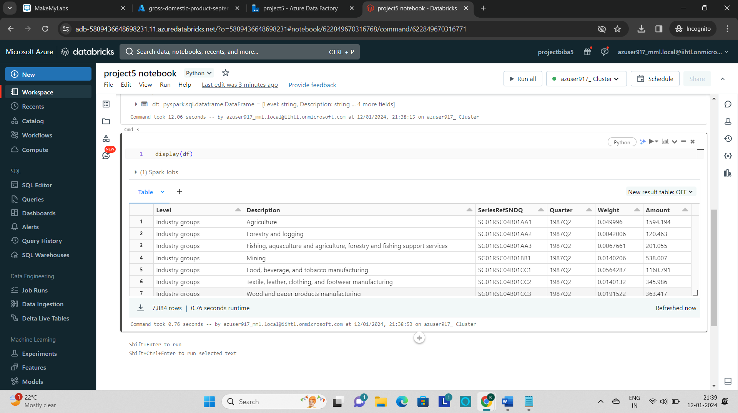

* Now perform some transformations on the file like **select, filter, sort, groupBy** and **drop** to process the data.
* **Select** is used to show the particular columns.

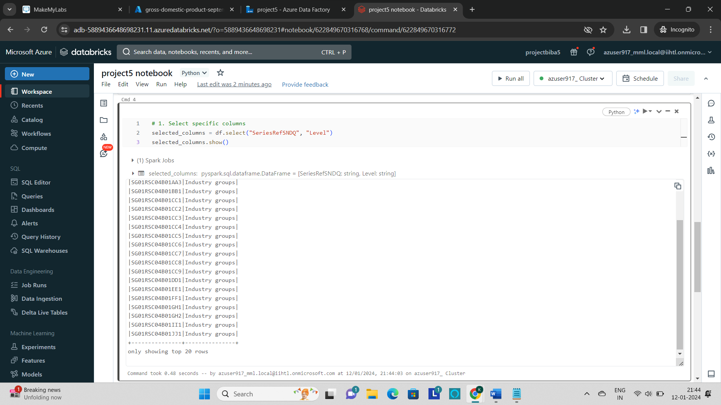

* **Filter()** is used to show the selected data based on the condition given.

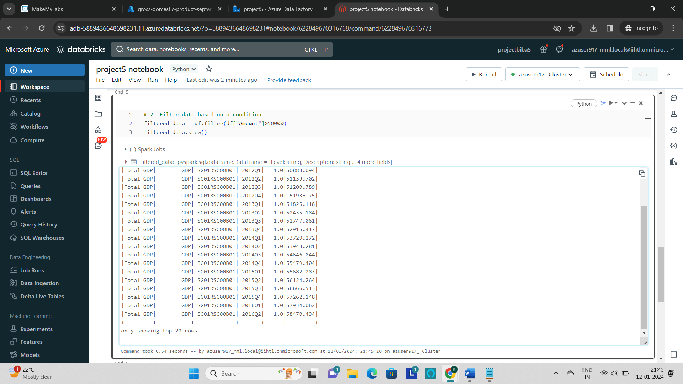

* **Sort()** command is used to sort the data either in the ascending or descending.

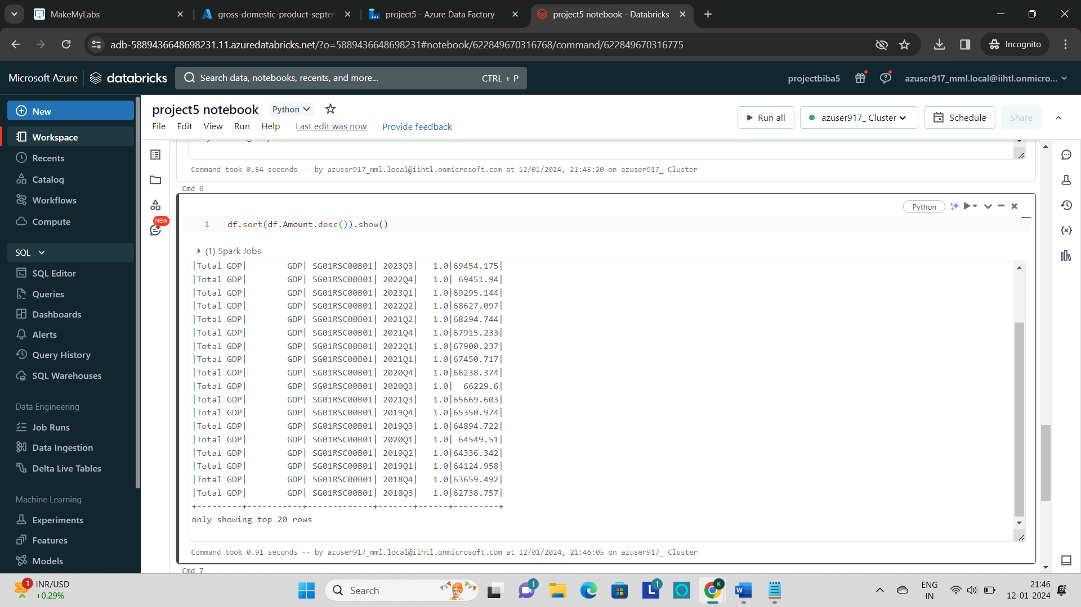

* **groupBy** is the command used to group all the rows having the same values.

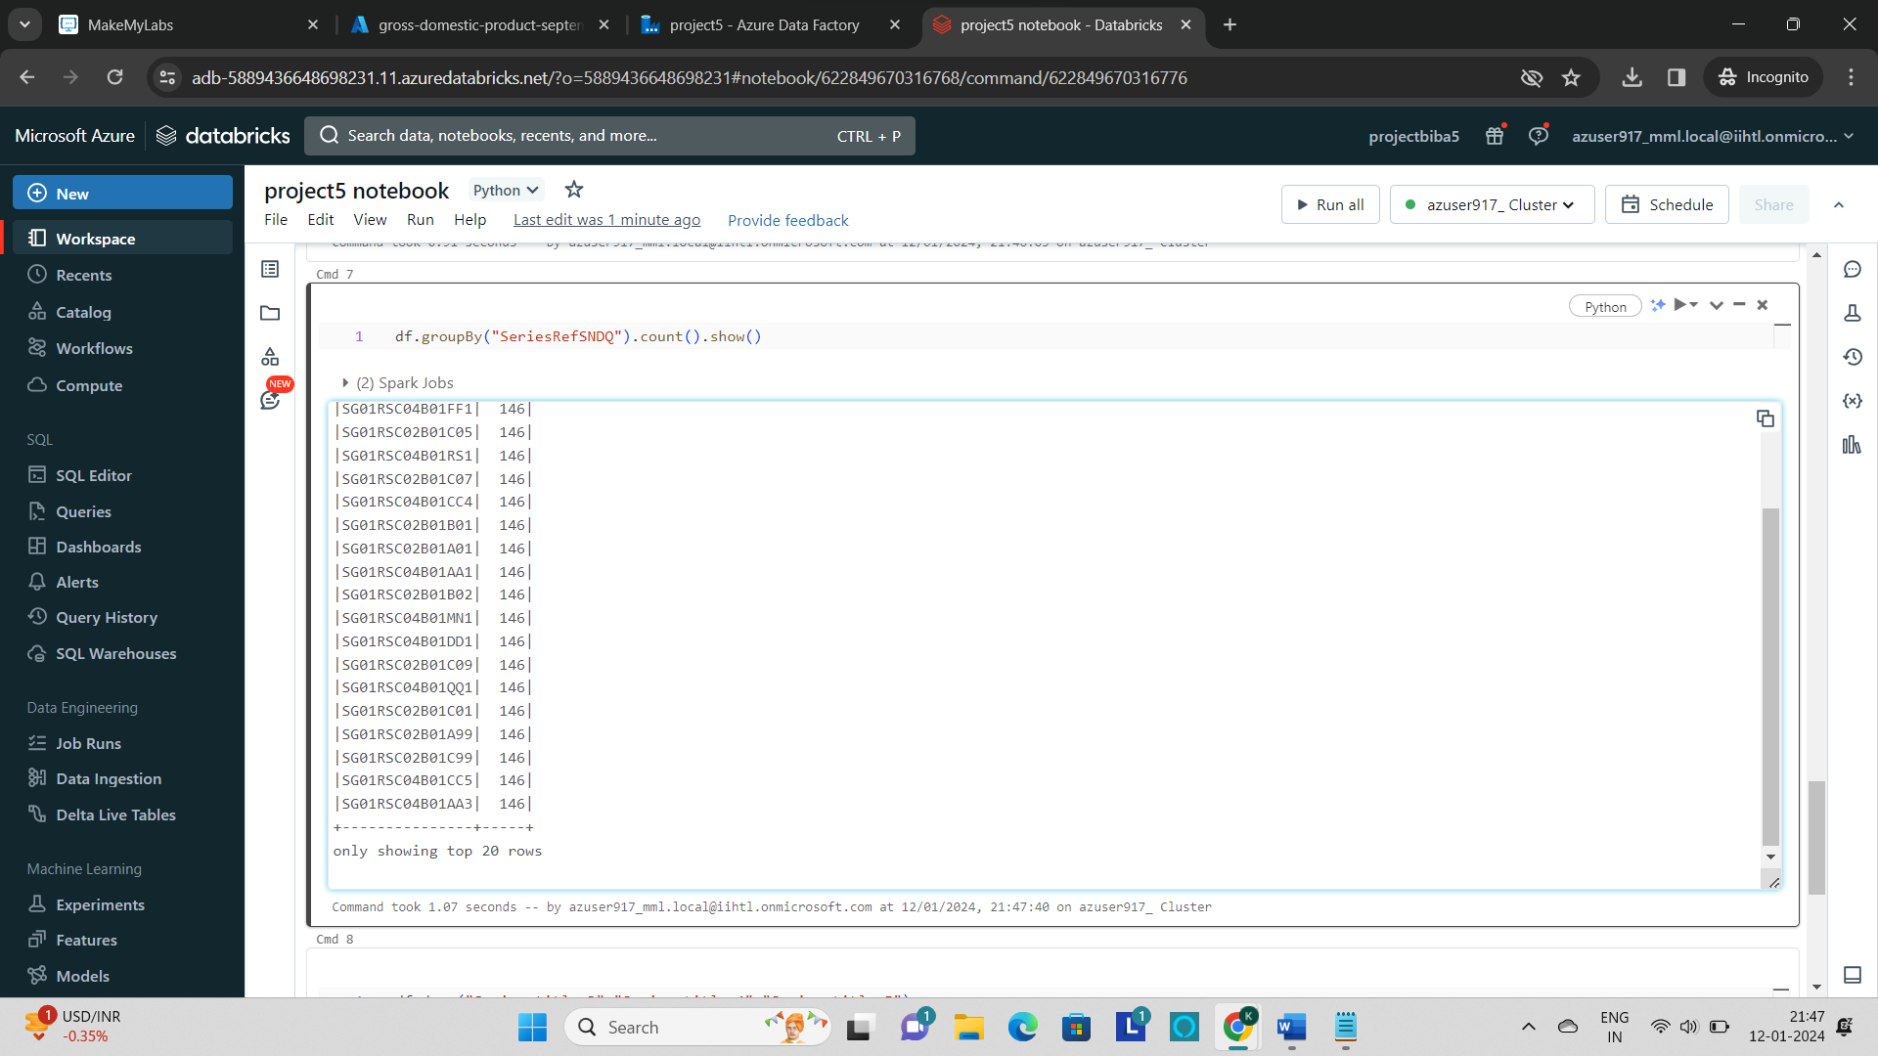

* **drop()** is used to delete the columns from the table.

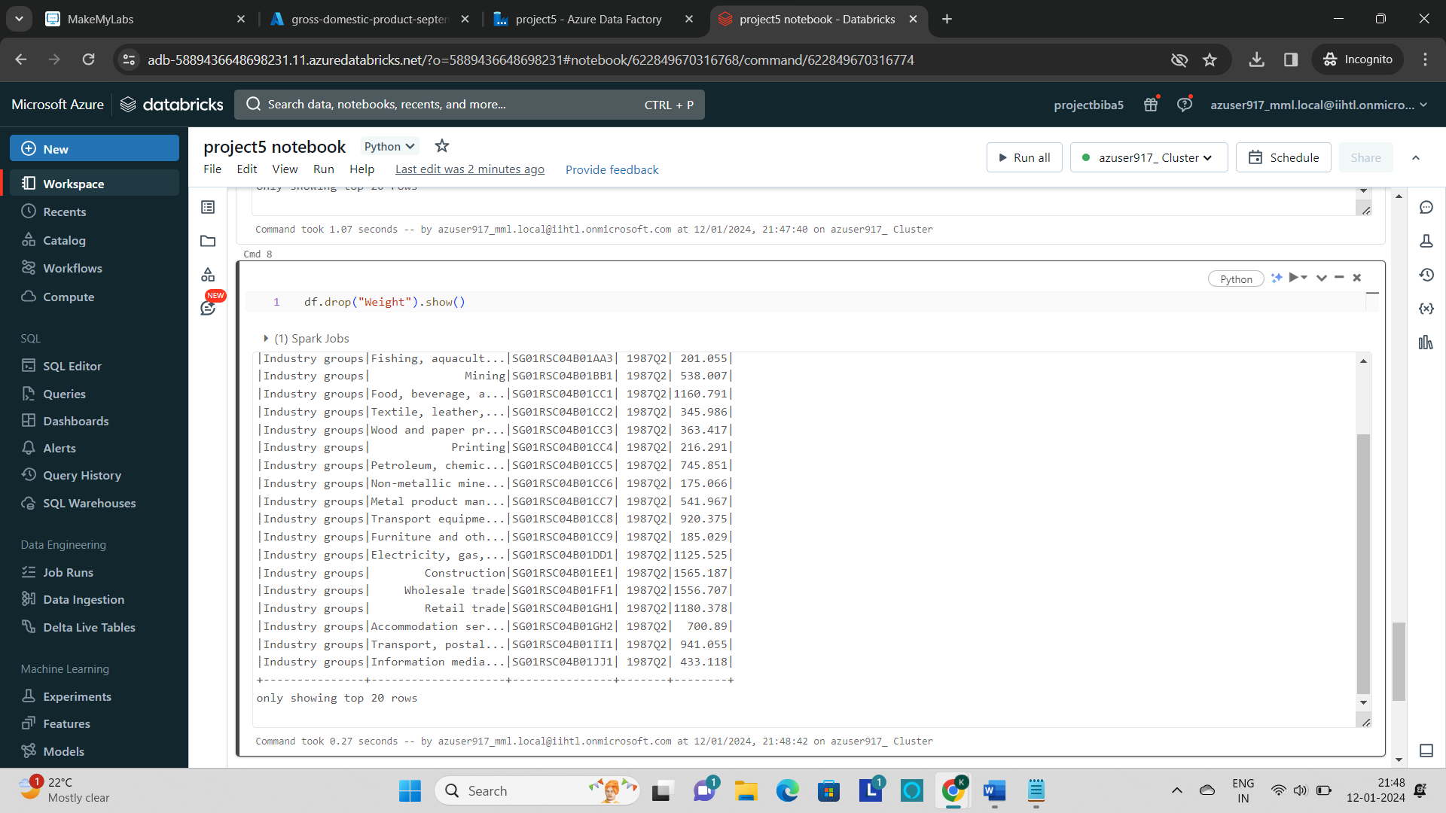

* After processing the data, go to **azure homepage** and select the **“data factories”.**

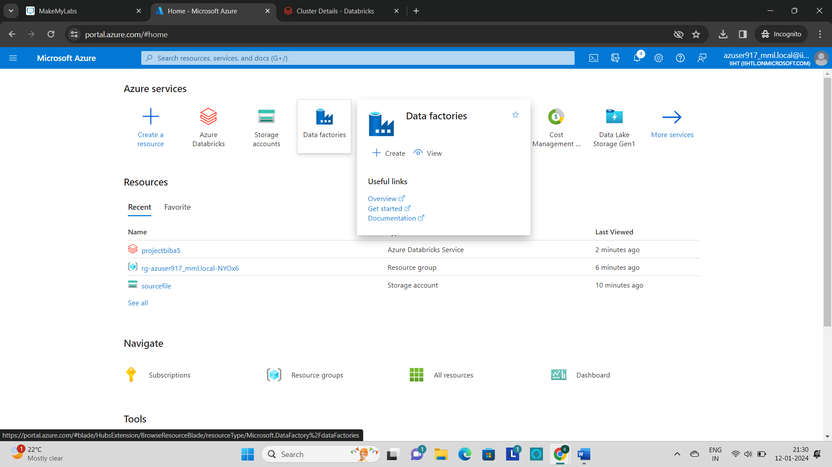

* Click on **“+ create”** to create a new data factory.

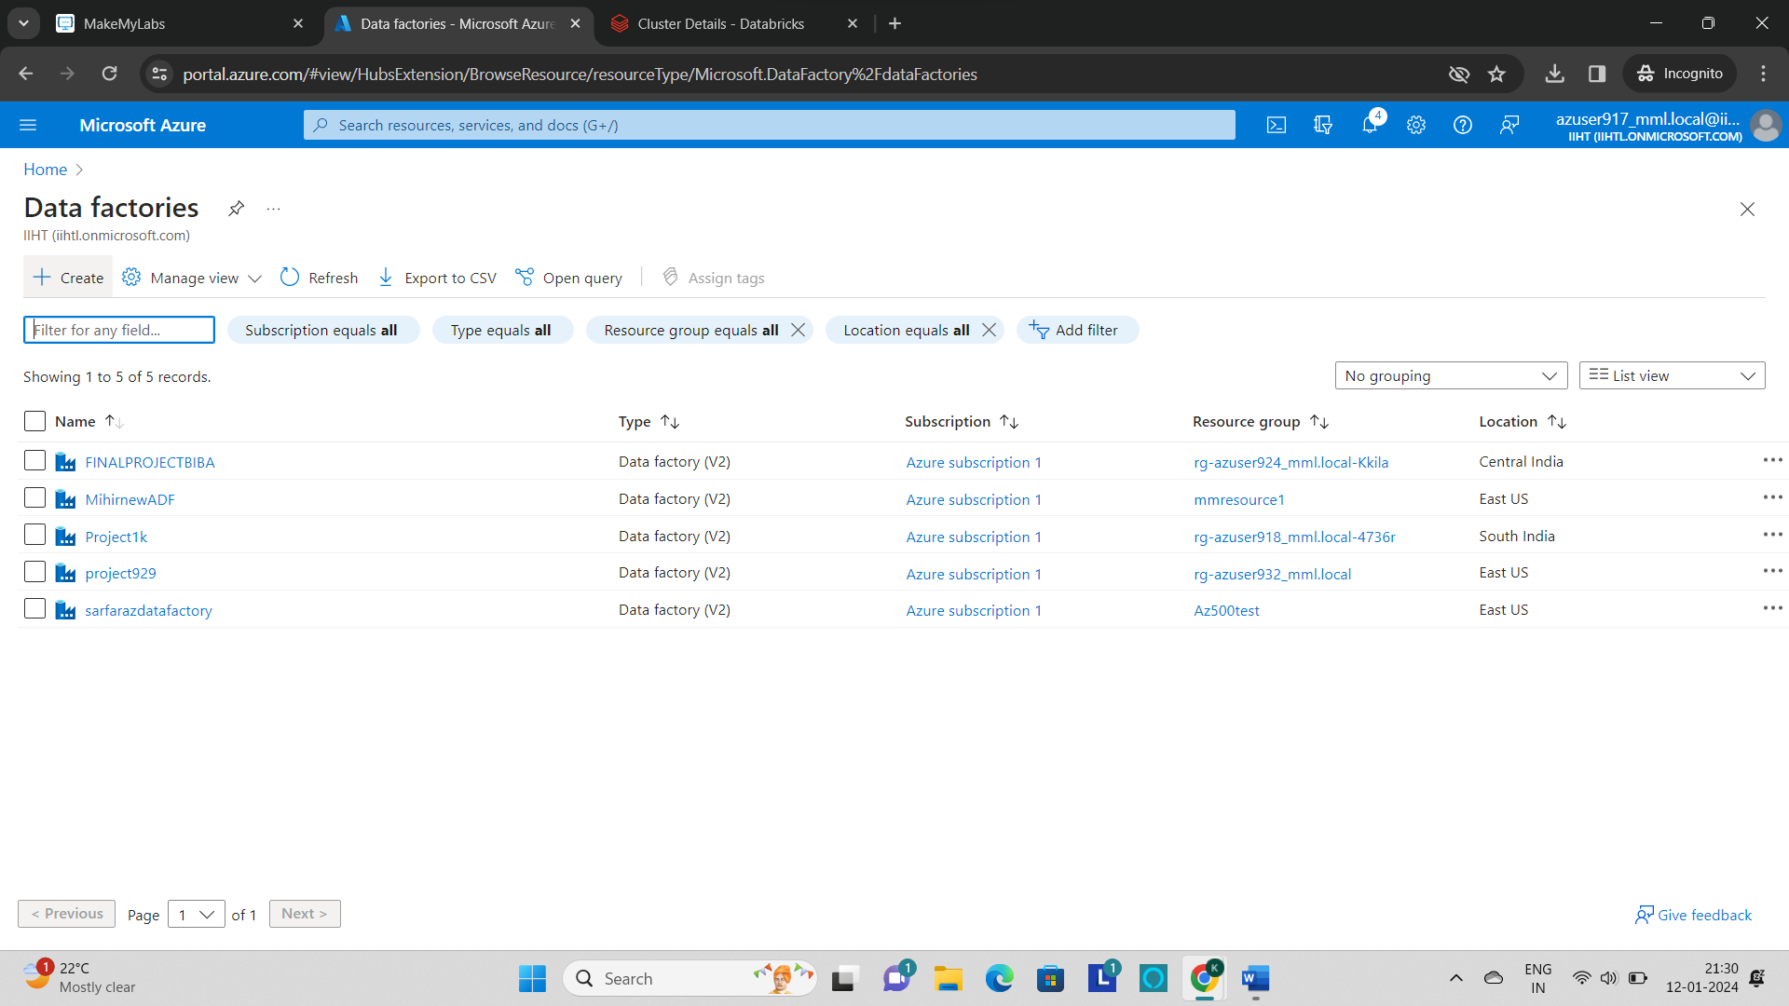

* Now fill the basic details like project and Instance details and then **“Review+create”.**

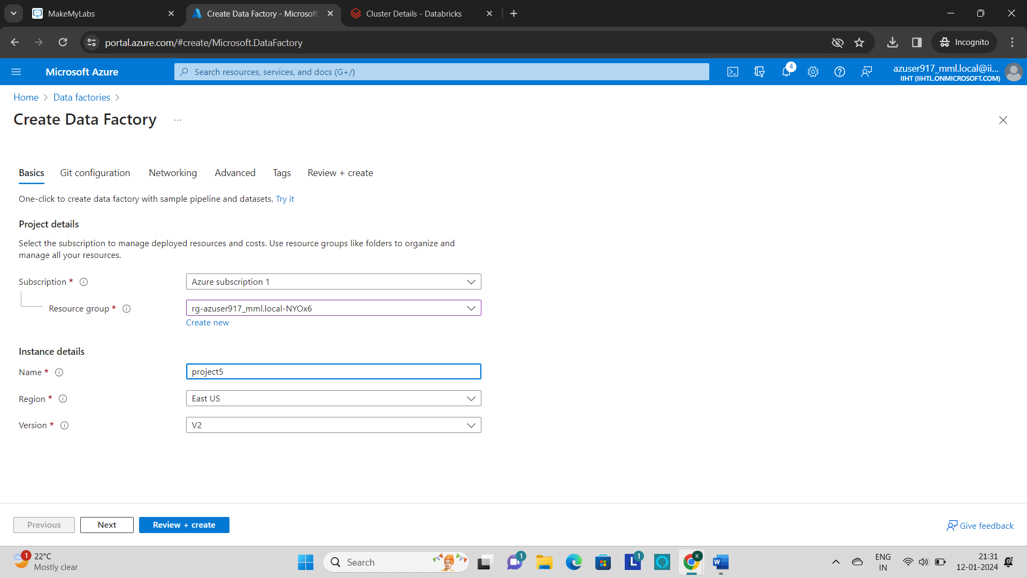

* After creating the data factory, click on **“Launch Studio”.**

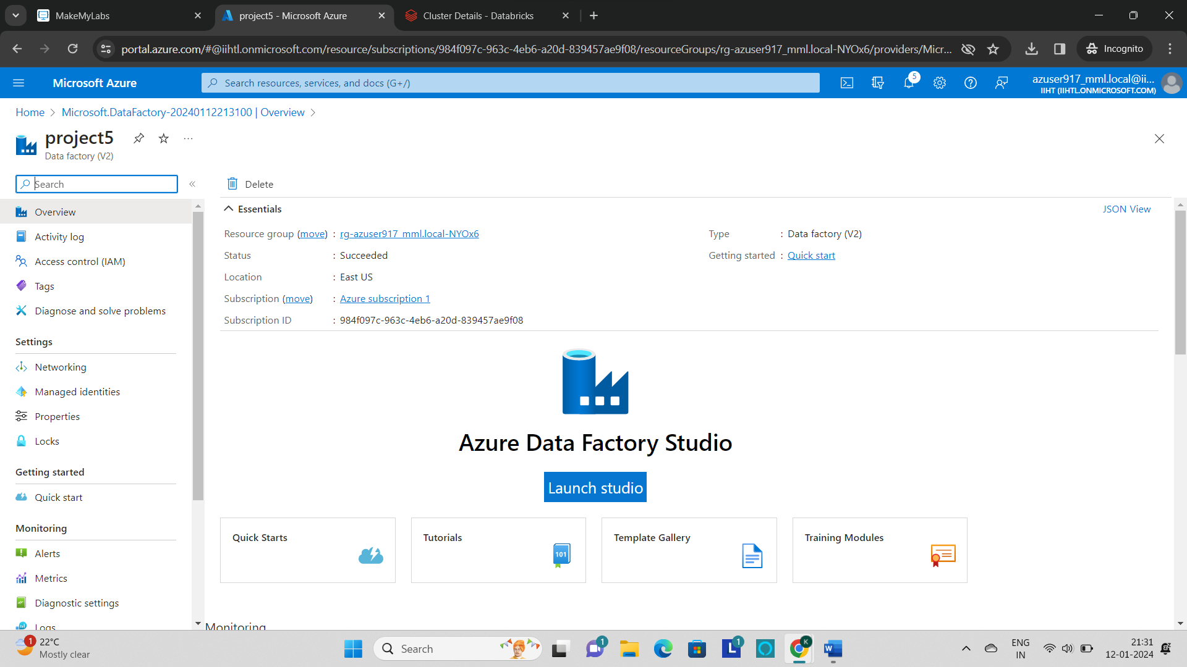

* In the data factory, click on **‘Author’** tab

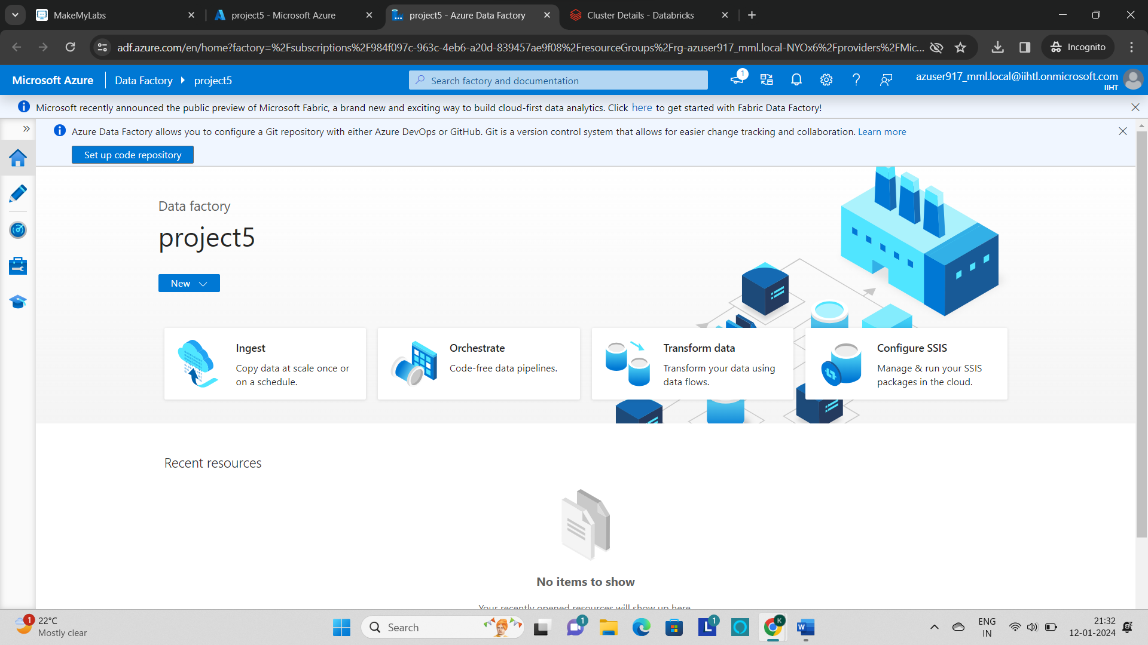

* Click on **+** to create a **new pipeline**.

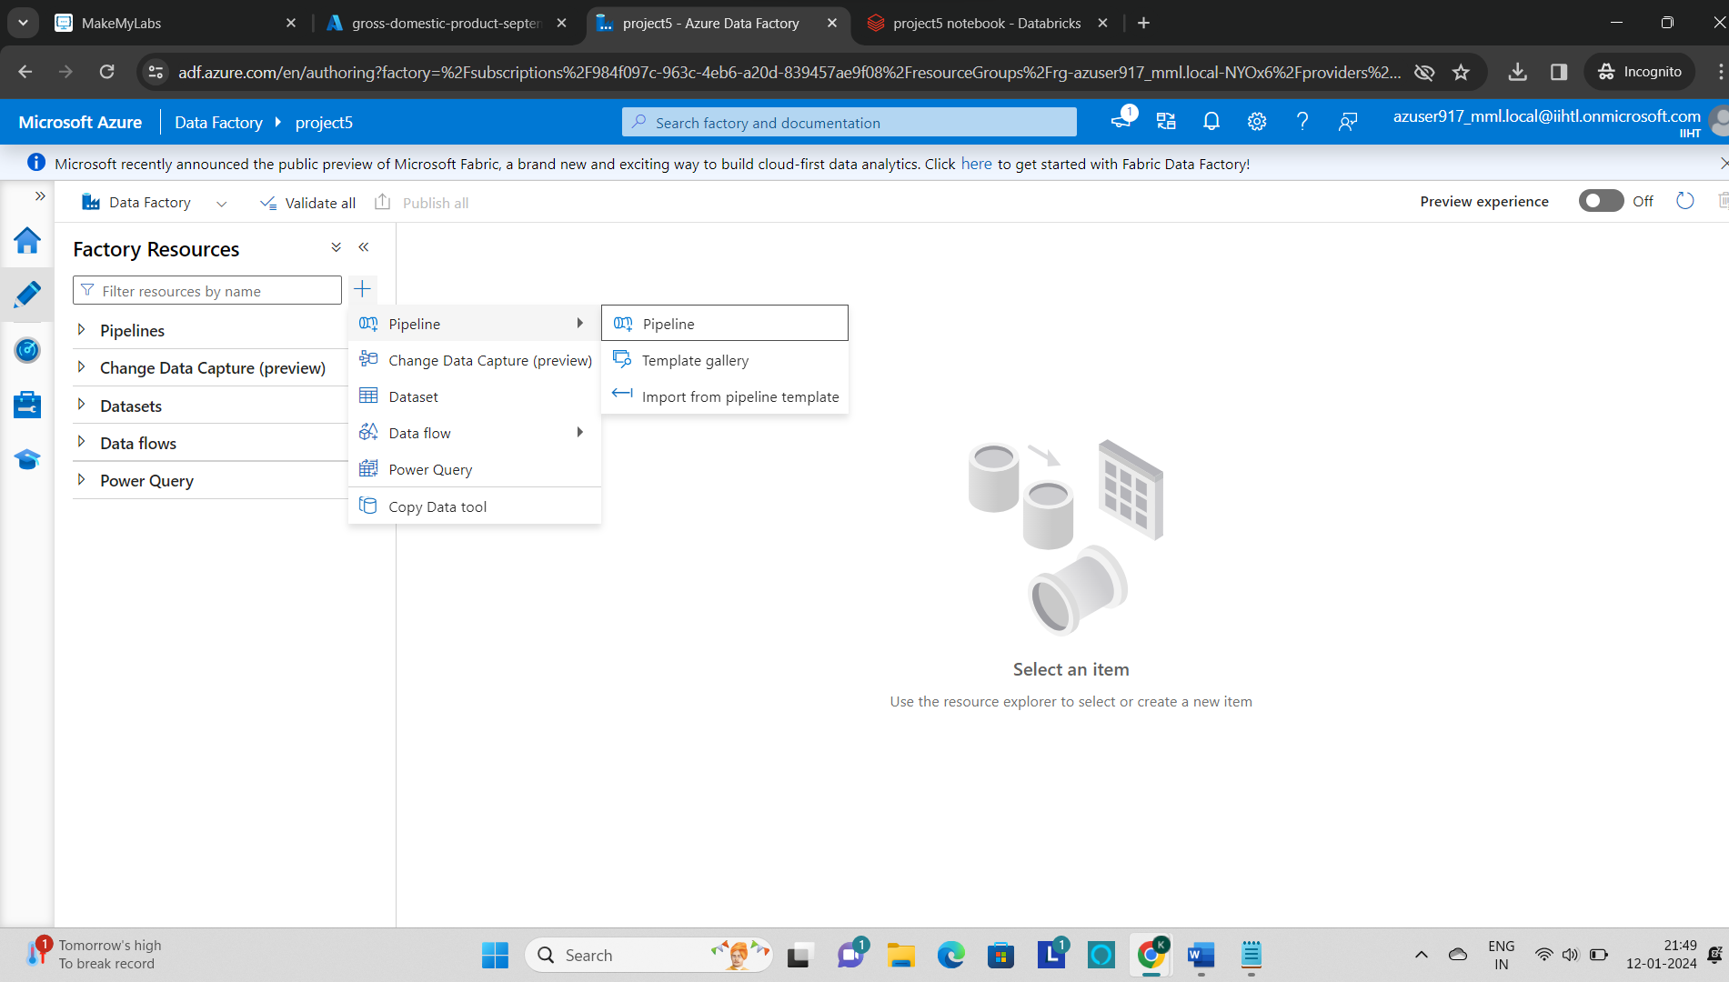

* Now include the **copy data activity** to the pipeline.

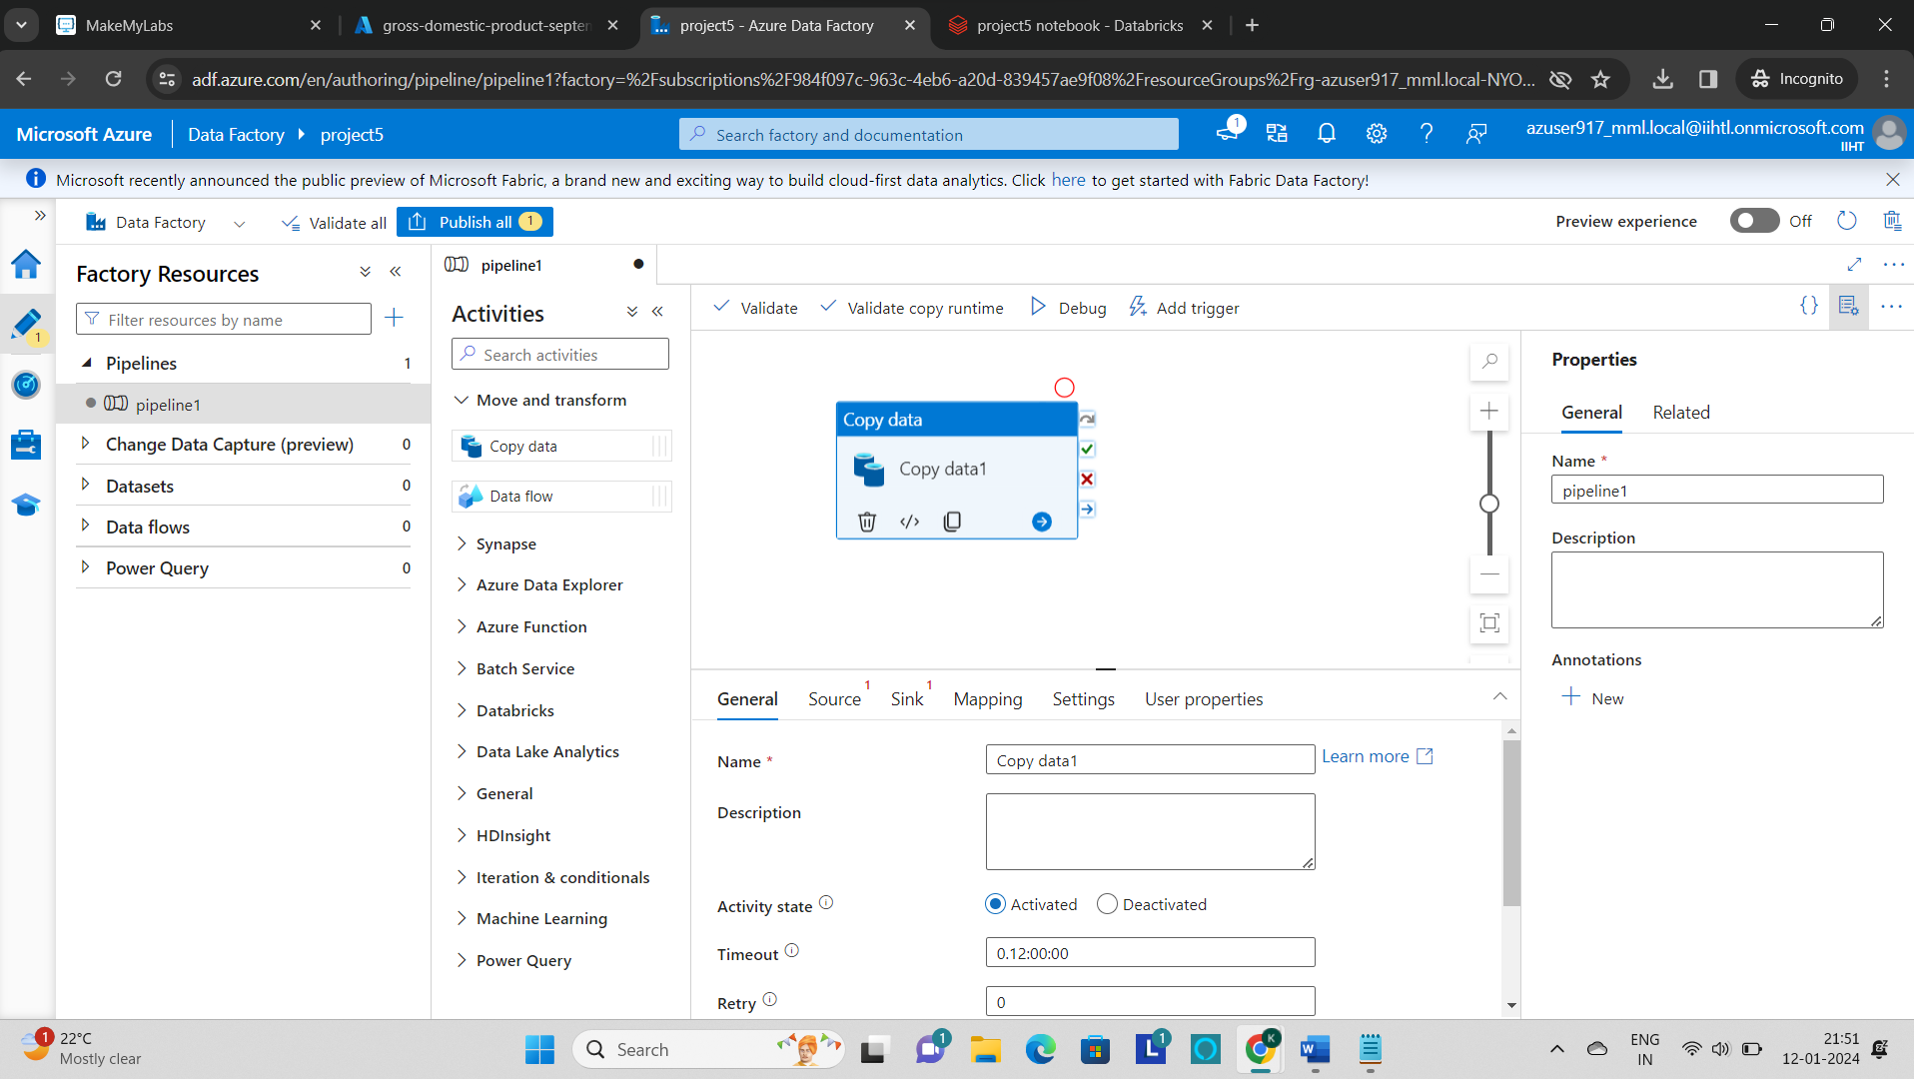

* Now provide the source details by clicking on the source and click on “**+**”.
* Select the **Azure blob storage** as a data store.

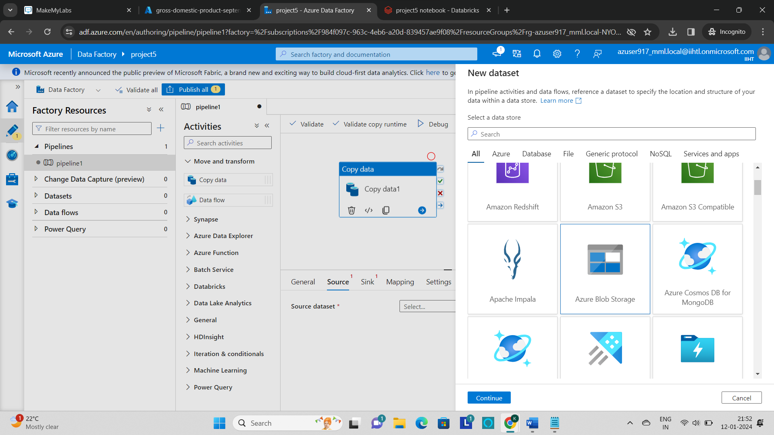

* Now select the **delimited text format** and click on continue.

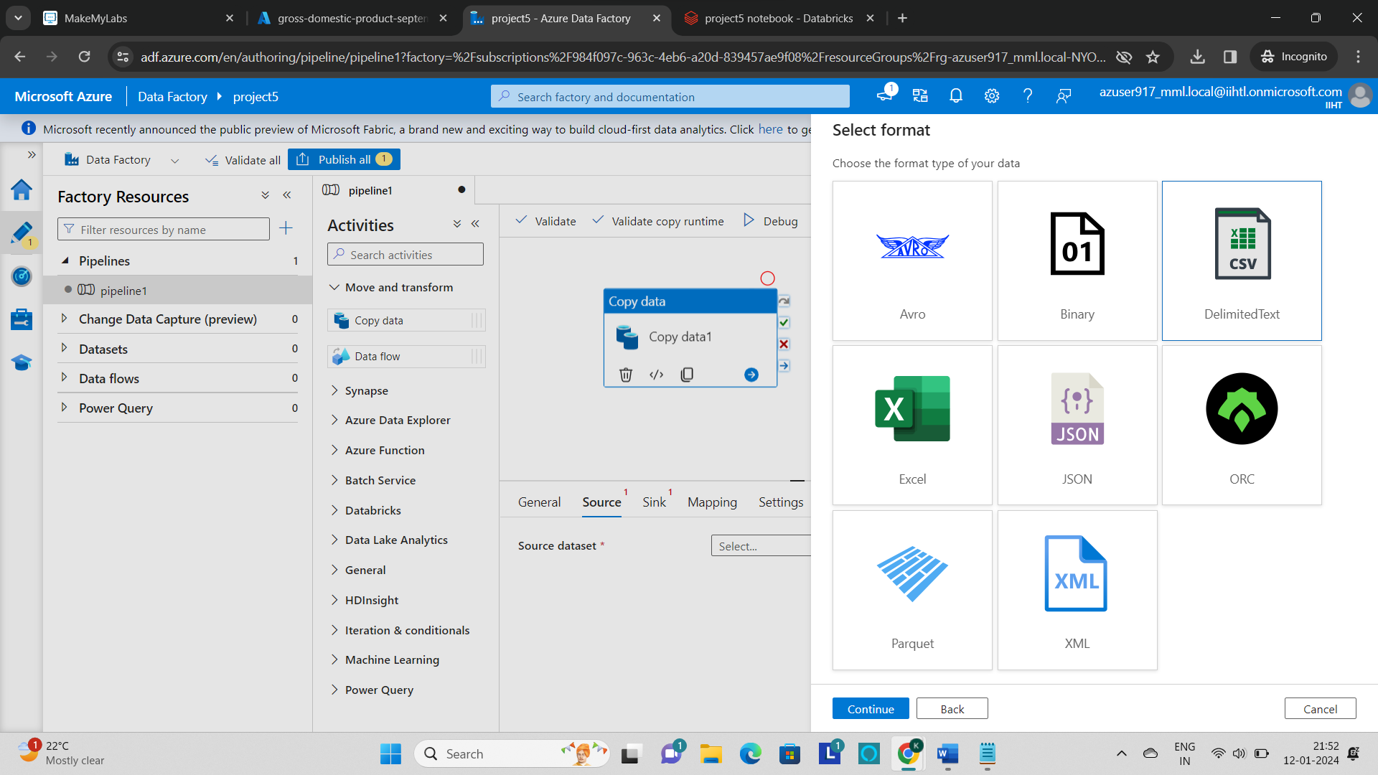

* Now create a linked service by providing the azure subscription and the storage account name.
* Test the connection and click on **“create”.**

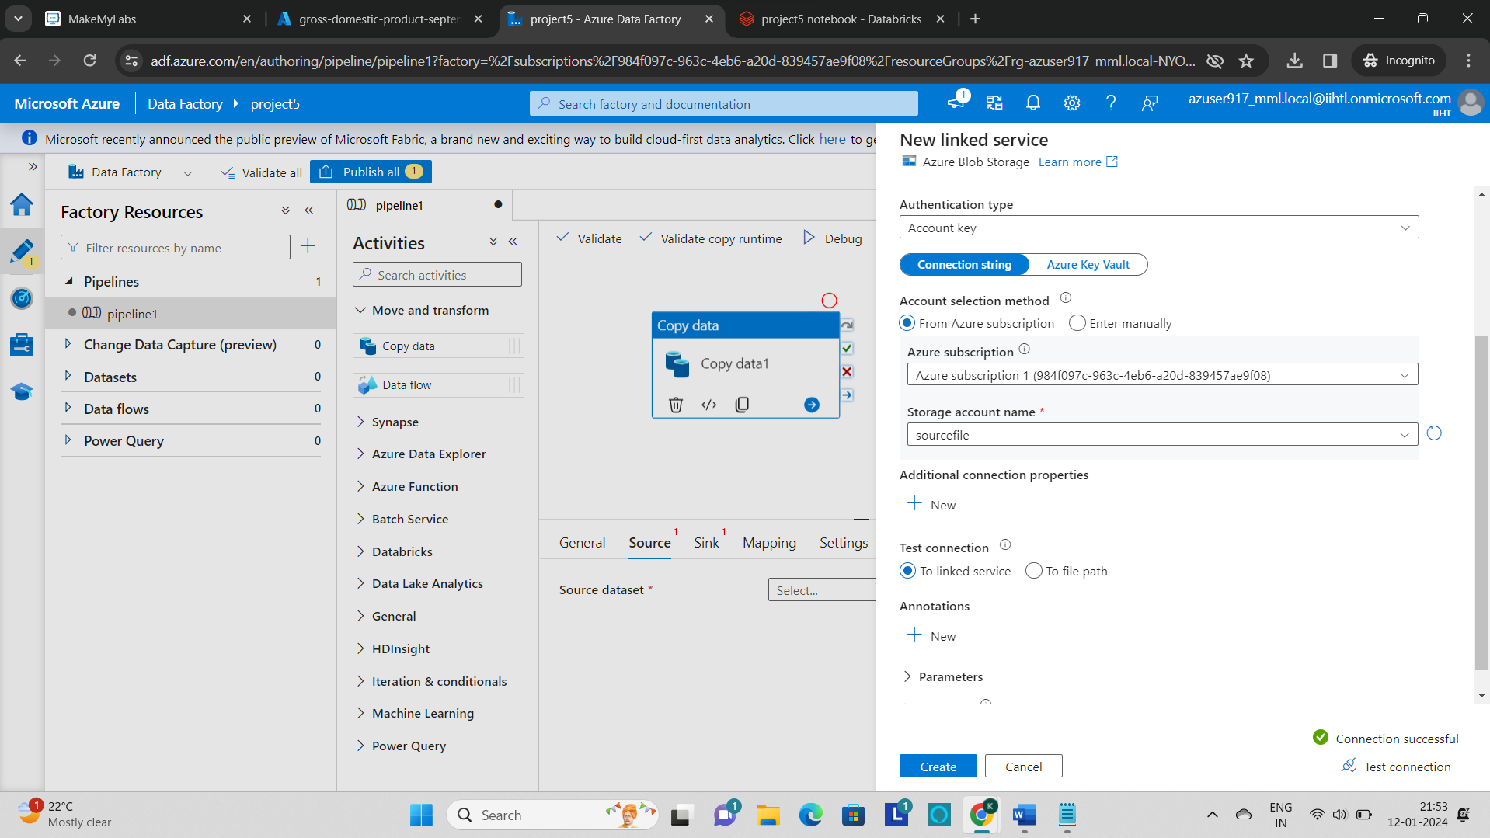

* Browse a file path for the **input file** and click on ok.

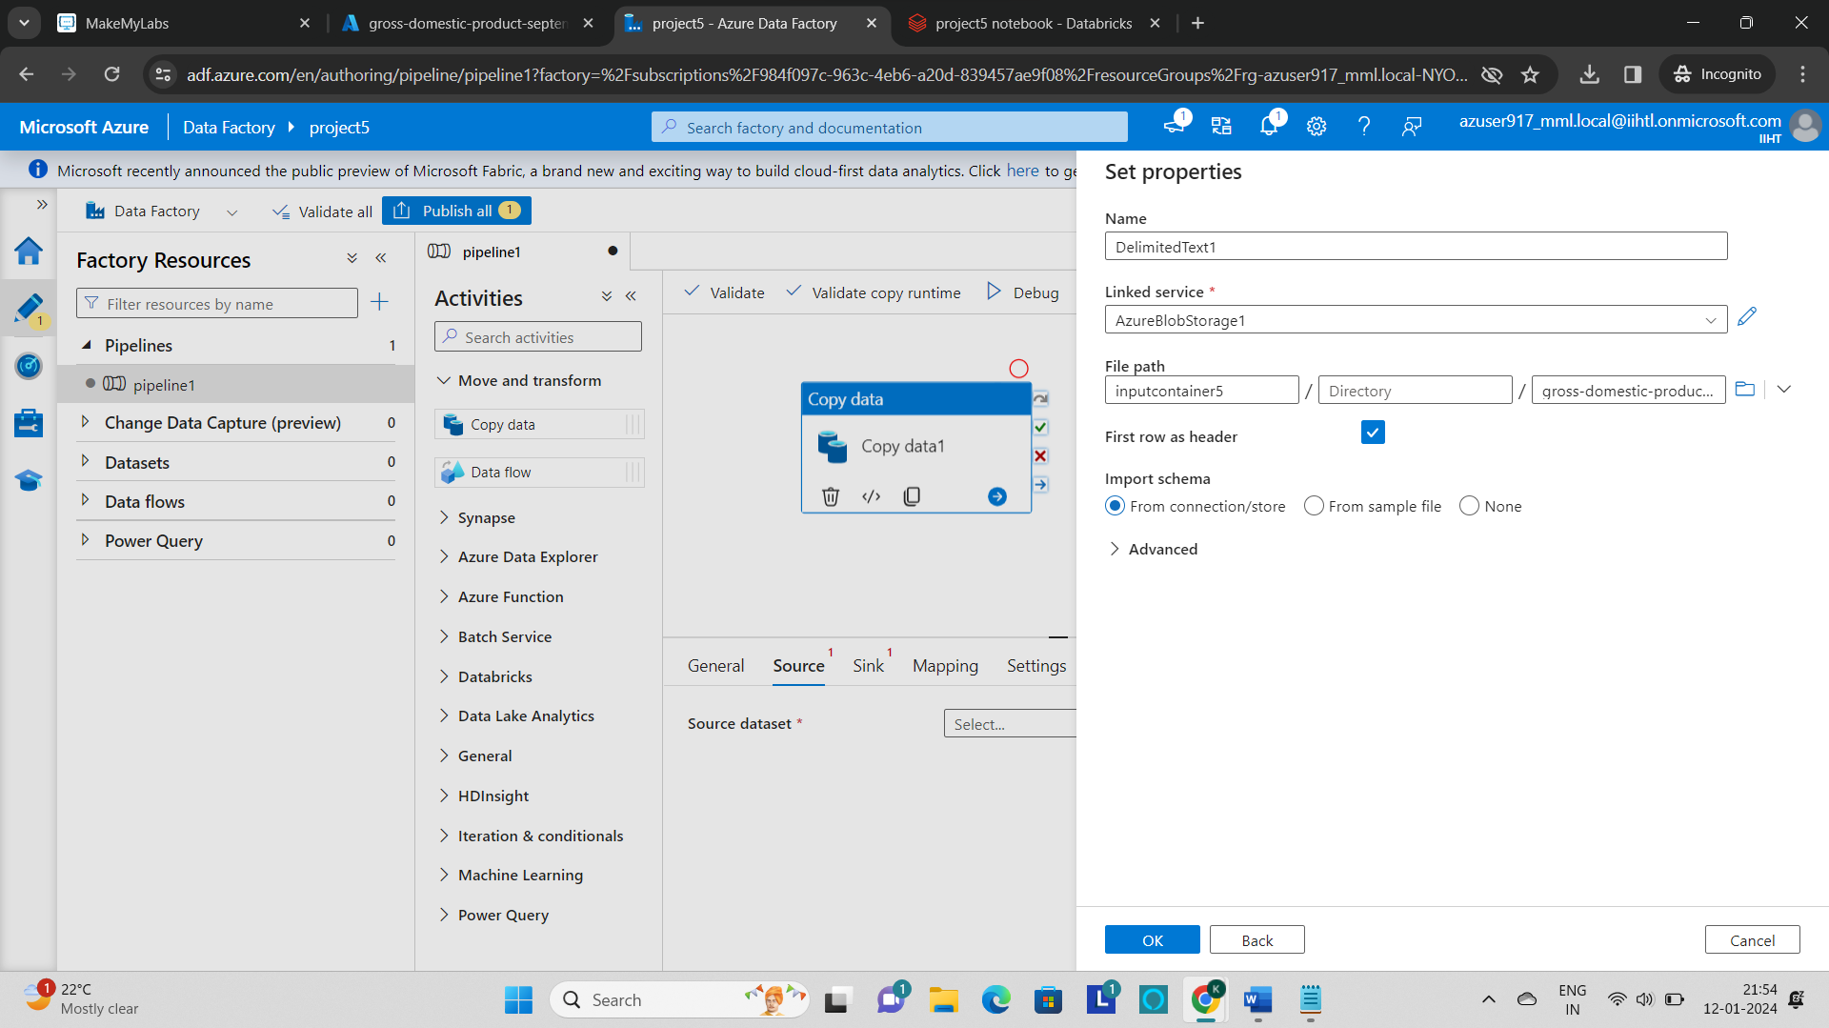

* Now create a **sink** for the file to be stored in the **destination.**
* To create this click on sink and click “**+**” and select the **azure blob storage** and select the file format as **“json”.**

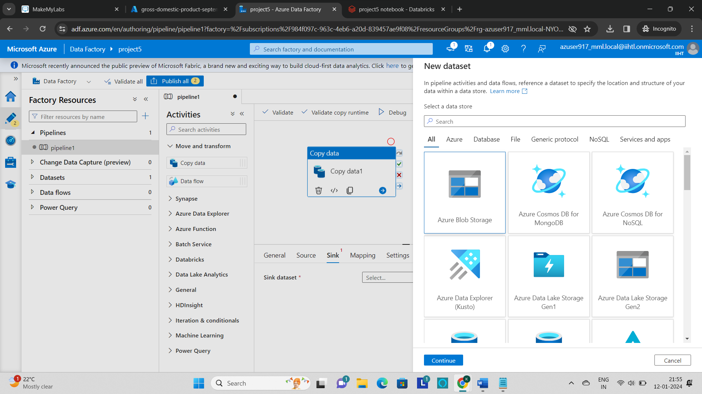

* Now create a new **linked service** for the storage account.

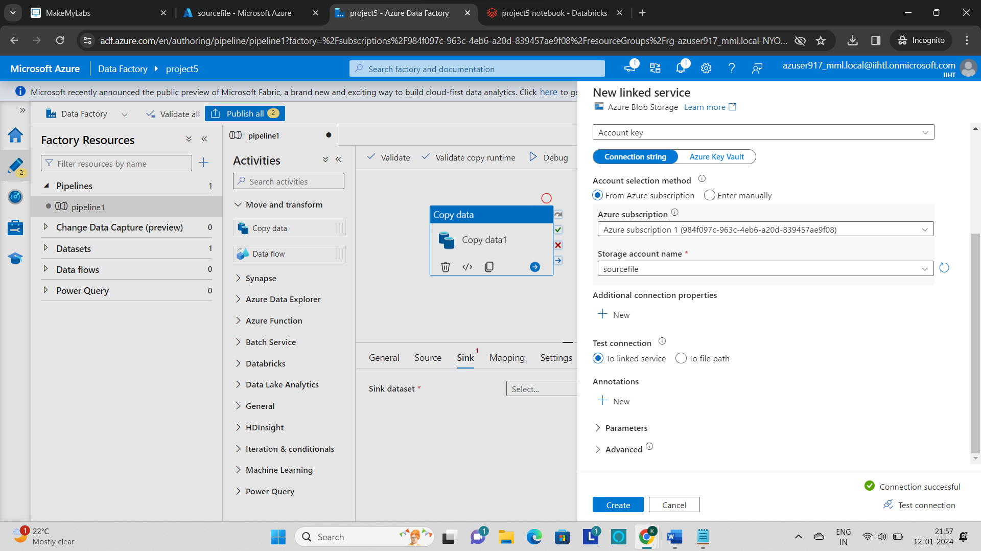

* Now set the **path for the file** to be stored.
* So to perform that create another container as **“output container”** in the storage account.

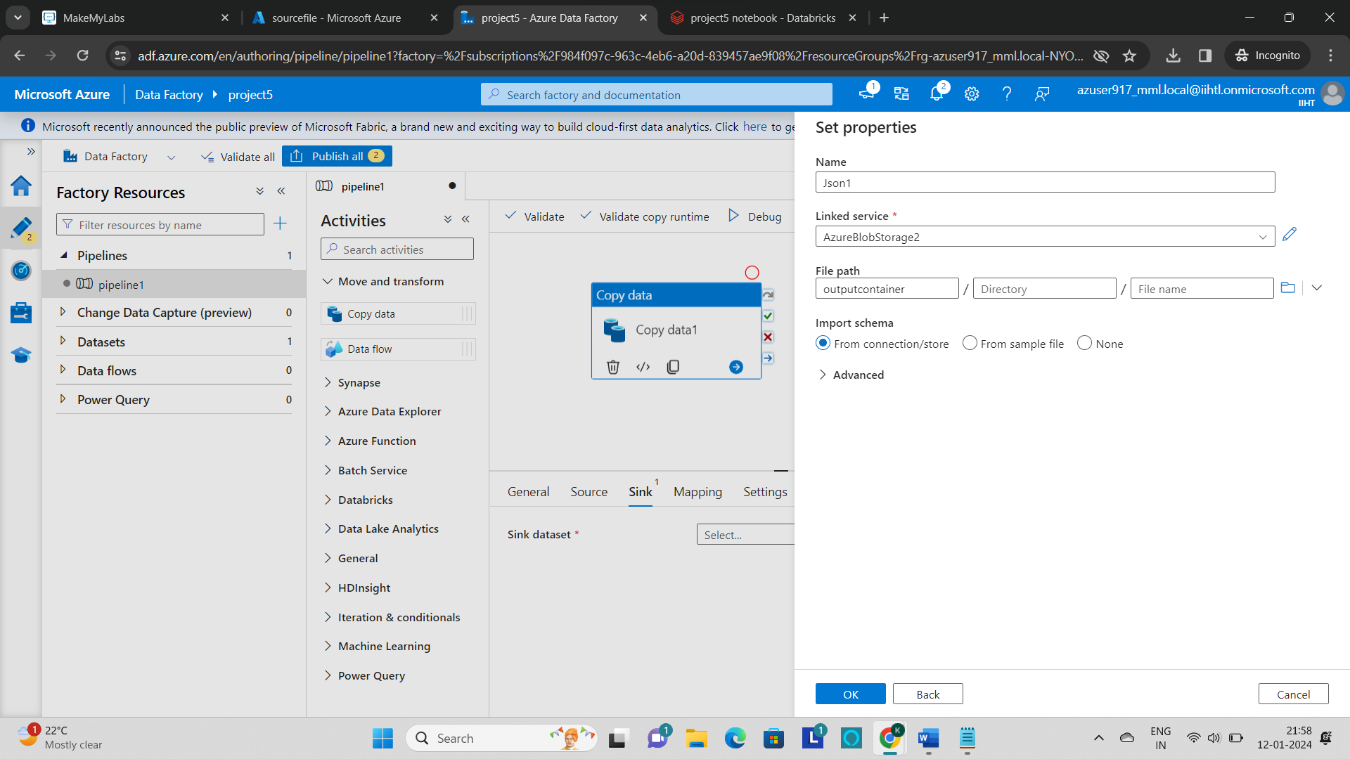

* Now create a **new trigger** and **debug** the pipeline.

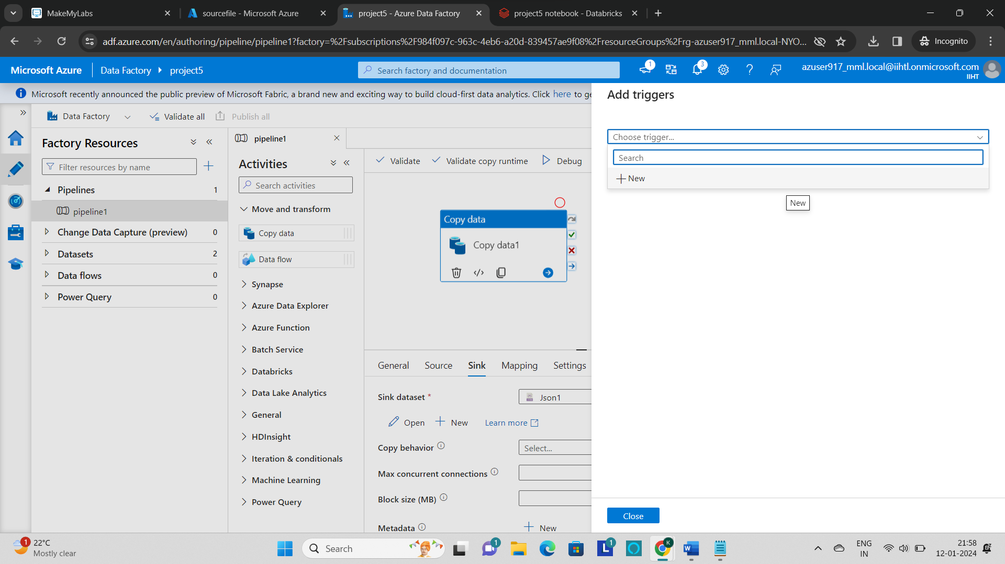

* The status of the pipeline can be monitored in the **output section.**

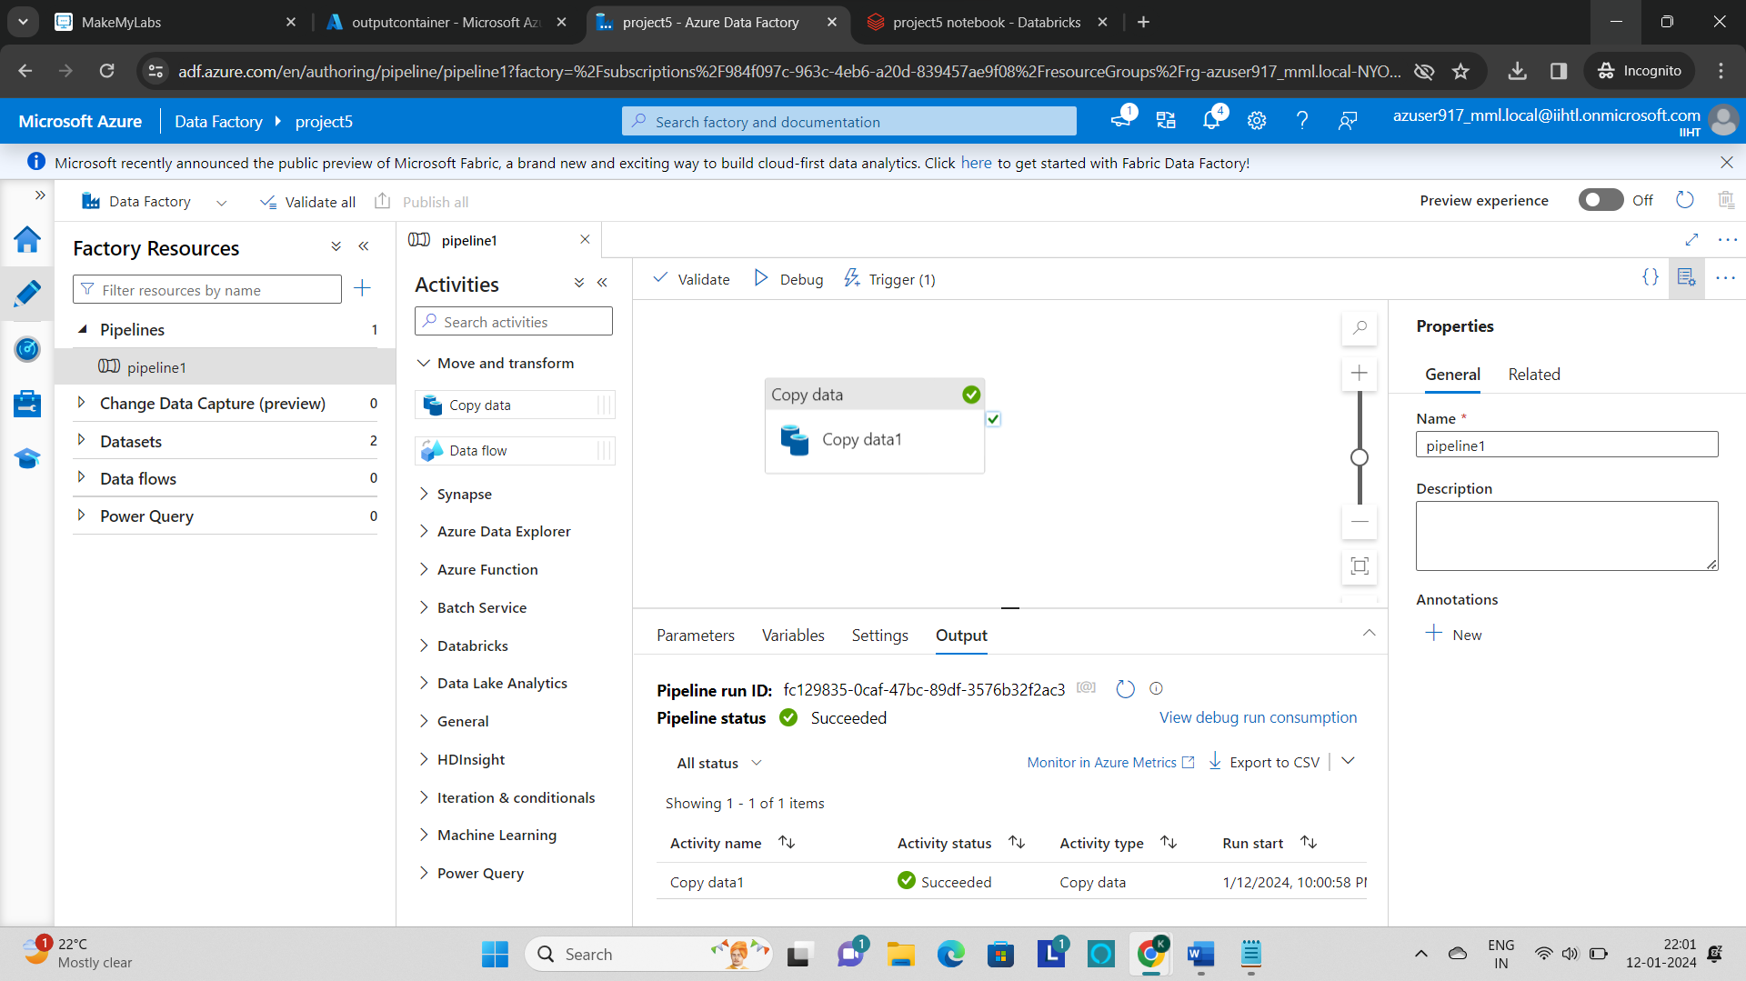

* After the successful completion of pipeline, go to the destination storage path and verify the file is copied or not.

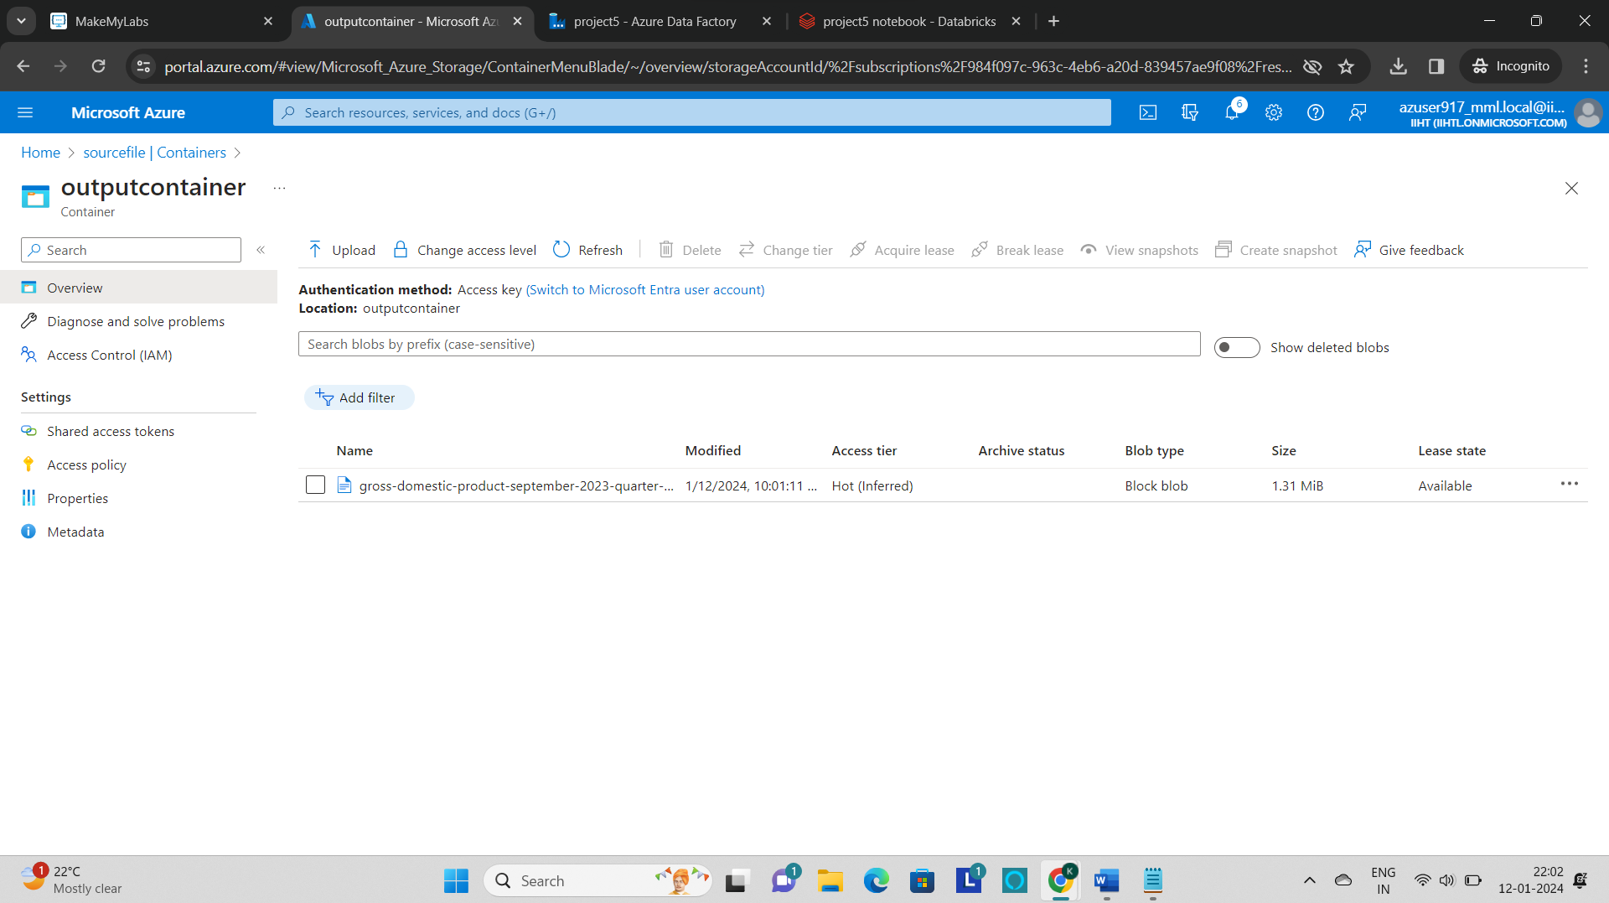

* The **json file** is copied to the **destination storage container**.
* We can view the json file by clicking and going to the edit and can also download the file to the local system by clicking on **“download”** option.

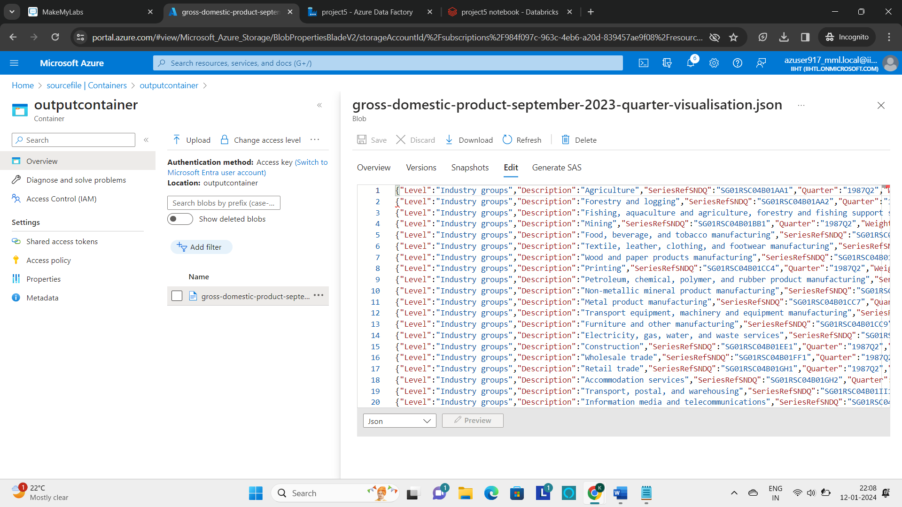

**Outputs:**

* As a part of processing the data some of the transformations are performed in the azure databricks.











* As a part of moving and organizing the data into the data lake storage, the json file is moved from source to the destination container with the leverage of azure data factory.

